

**Department of Information Technology**

# **CERTIFICATE**

This is to certify that **Chirag A Choudhary** of**D15A**semester**VI,**have successfully completed necessary experiments in the **MAD & PWA Lab** under my supervision in **VES** **Institute of Technology** during the academic year **2024-2025.**

Lab Assistant Subject Teacher

**Mrs. Kajal Joseph**

Principal Head of Department

**Dr. Mrs. Shalu Chopra**

**Name of the Course :** MAD & PWA Lab **Course Code :** ITL604

**Year/Sem/Class :** D15A/D15B **A.Y.:** 24-25

**Faculty Incharge** : Mrs. Kajal Joseph.

**Lab Teachers :** Mrs. Kajal Joseph.

**Email :** [kajal.jewani@ves.ac.in](mailto:kajal.jewani@ves.ac.in)

**Programme Outcomes**: The graduate will be able to:

PO1) Basic Engineering knowledge: An ability to apply the fundamental knowledge in mathematics, science and engineering to solve problems in Computer engineering.

PO2) Problem Analysis: Identify, formulate, research literature and analyze computer engineering problems reaching substantiated conclusions using first principles of mathematics, natural sciences and computer engineering and sciences.

PO3) Design/ Development of Solutions: Design solutions for complex computer engineering problems and design system components or processes that meet specified needs with appropriate consideration for public health and safety, cultural, societal and environmental considerations.

PO4) Conduct investigations of complex engineering problems using research-based knowledge and research methods including design of experiments, analysis and interpretation of data and synthesis of information to provide valid conclusions.

PO5) Modern Tool Usage: Create, select and apply appropriate techniques, resources and modern computer engineering and IT tools including prediction and modeling to complex engineering activities with an understanding of the limitations.

PO6) The Engineer and Society: Apply reasoning informed by contextual knowledge to assess societal, health, safety, legal and cultural issues and the consequent responsibilities relevant to computer engineering practice.

PO7) Environment and Sustainability: Understand the impact of professional computer engineering solutions in societal and environmental contexts and demonstrate knowledge of and need for sustainable development.

PO8) Ethics: Apply ethical principles and commit to professional ethics and responsibilities and norms of computer engineering practice.

PO9) Individual and Team Work: Function effectively as an individual, and as a member or leader in diverse teams and in multidisciplinary settings.

PO10) Communication: Communicate effectively on complex engineering activities with the engineering community and with society at large, such as being able to comprehend and write effective reports and design documentation, make effective presentations and give and receive clear instructions.

PO11) Project Management and Finance: Demonstrate knowledge and understanding of computer engineering and management principles and apply these to one's own work, as a member and leader in a team, to manage projects and in multidisciplinary environments.

PO12) Life-long Learning: Recognize the need for and have the preparation and ability to engage in independent and lifelong learning in the broadest context of technological change.

**Program specific Outcomes**

**PSO1)** An ability to manage and analyze data / information effectively for making better decisions.

**PSO2)** Demonstrate the ability to use state of the art technologies and tools including Free and Open Source Software (FOSS) tools in developing software.

**Lab Objectives:**

|  |  |
| --- | --- |
| **Sr. No.** | **Lab Objectives** |
| **The Lab experiments aims:** | |
| **1** | Learn the basics of the Flutter framework. |
| **2** | Develop the App UI by incorporating widgets, layouts, gestures and animation |
| **3** | Create a production ready Flutter App by including files and firebase backend service. |
| **4** | Learn the Essential technologies, and Concepts of PWAs to get started as quickly and efficiently as possible |
| **5** | Develop responsive web applications by combining AJAX development techniques with the jQuery JavaScript library. |
| **6** | Understand how service workers operate and also learn to Test and Deploy PWA. |

**Lab Outcomes:**

|  |  |  |  |
| --- | --- | --- | --- |
| **Sr. No.** | | **Lab Outcomes** | **Cognitive levels of attainment as per Bloom’s Taxonomy** |
| **On Completion of the course the learner/student should be able to:** | | | |
| **1** | Understand cross platform mobile application development using Flutter framework | | L1, L2 |
| **2** | Design and Develop interactive Flutter App by using widgets, layouts, gestures and animation | | L3 |
| **3** | Analyze and Build production ready Flutter App by incorporating backend services and deploying on Android / iOS | | L3, L4 |
| **4** | Understand various PWA frameworks and their requirements | | L1, L2 |
| **5** | Design and Develop a responsive User Interface by applying PWA Design techniques | | L3 |
| **6** | Develop and Analyse PWA Features and deploy it over app hosting solutions | | L3, L4 |

**Index**

|  |  |  |  |  |  |
| --- | --- | --- | --- | --- | --- |
| **Sr.No** | **Experiment Title** | **LO** | **DOP** | **DOS** | **Grade** |
| **1.** | To install and configure the Flutter Environment | LO1 |  |  |  |
| **2.** | To design Flutter UI by including common widgets. | LO2 |  |  |  |
| **3.** | To include icons, images, fonts in Flutter app | LO2 |  |  |  |
| **4.** | To create an interactive Form using form widget | LO2 |  |  |  |
| **5.** | To apply navigation, routing and gestures in Flutter App | LO2 |  |  |  |
| **6.** | To Connect Flutter UI with fireBase database | LO3 |  |  |  |
| **7.** | To write meta data of your Ecommerce PWA in a Web app manifest file to enable “add to homescreen feature”. | LO4 |  |  |  |
| **8.** | To code and register a service worker, and complete the install and activation process for a new service worker for the E-commerce PWA | LO5 |  |  |  |
| **9.** | To implement Service worker events like fetch, sync and push for E-commerce PWA | LO5 |  |  |  |
| **10.** | To study and implement deployment of Ecommerce PWA to GitHub Pages. | LO5 |  |  |  |
| **11.** | To use google Lighthouse PWA Analysis Tool to test the PWA functioning. | LO6 |  |  |  |
| **12.** | Assignment-1 | LO1,LO2,LO3 |  |  |  |
| **13.** | Assignment-2 | LO4,LO5,LO6 |  |  |  |

MAD & PWA Lab

Journal

|  |  |
| --- | --- |
| Experiment No. | 01 |
| Experiment Title. | To install and configure the Flutter Environment |
| Roll No. | 10 |
| Name | Chirag A Choudhary |
| Class | D15A |
| Subject | MAD & PWA Lab |
| Lab Outcome | LO1: Understand cross platform mobile application development using Flutter framework |
| Grade: |  |

**AIM: - Installation and Configuration of Flutter Environment.**

Step 1: Go to the official Flutter website: <https://docs.flutter.dev/get-started/install>

Step 2: To download the latest Flutter SDK, click on the Windows icon > Android

Step 3: For Windows, download the stable release (a .zip file).

Step 4: Extract the ZIP file to a folder (e.g., C:\flutter)

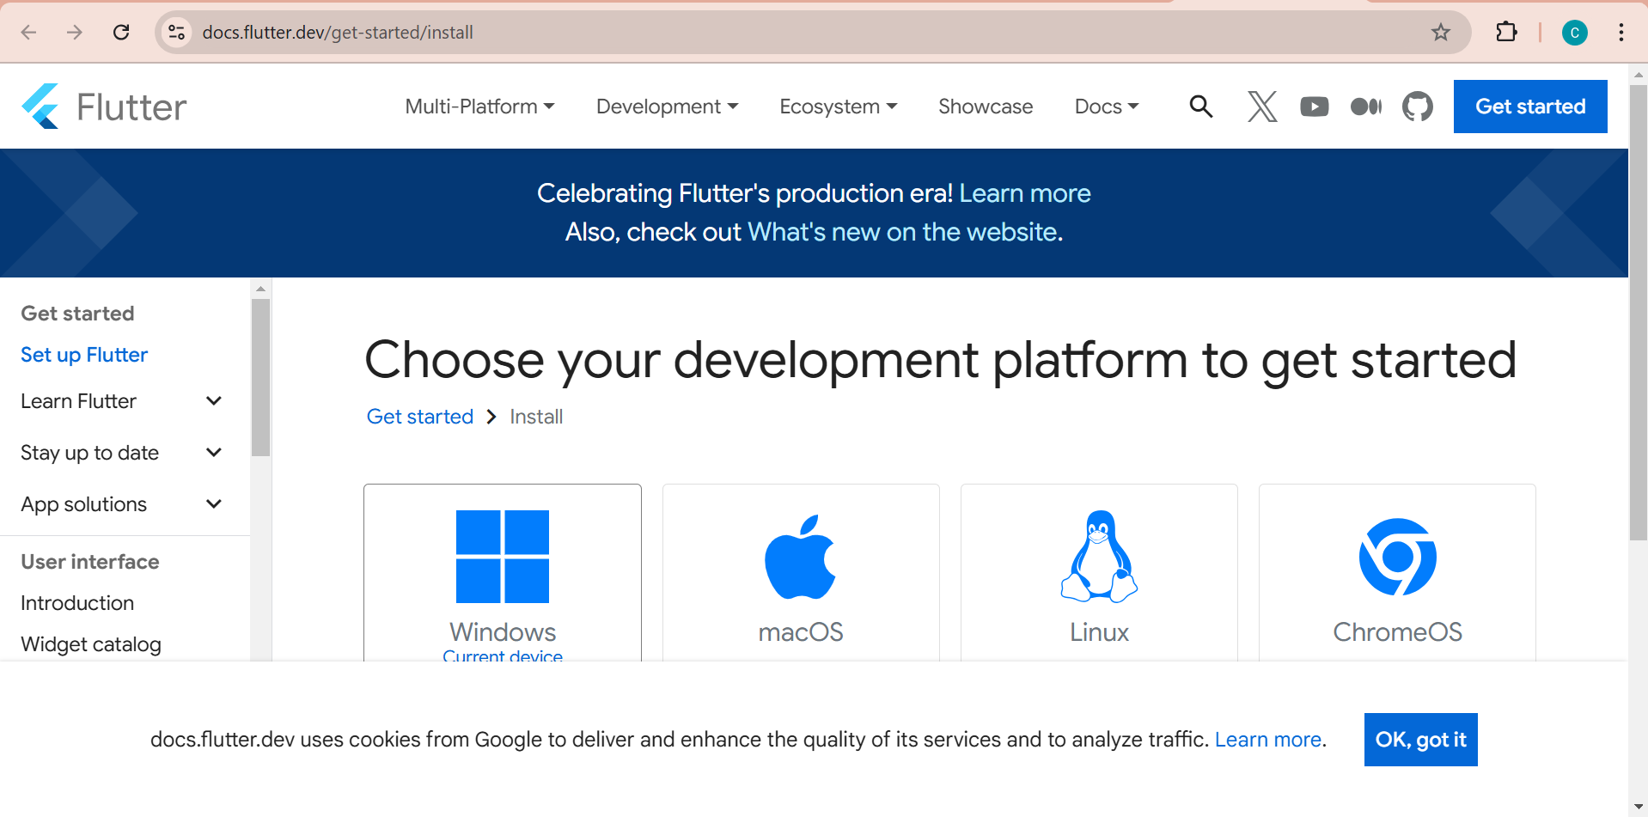

Step 5 :- Add Flutter to System PATH Right-click on the Start Menu > System > Advanced system settings > Environment Variables. Under System Variables, find Path and click Edit. Add the full path to the flutter/bin directory (e.g., C:\flutter\bin).

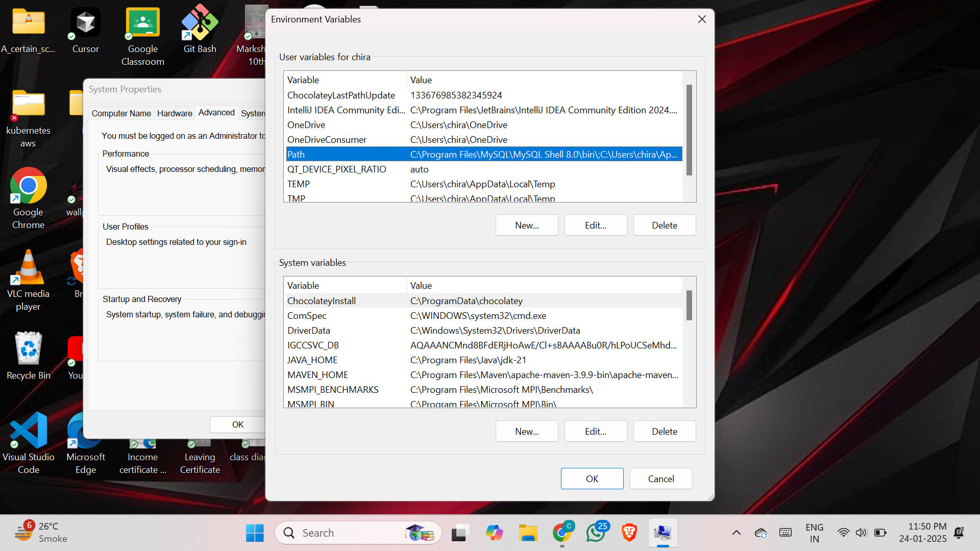

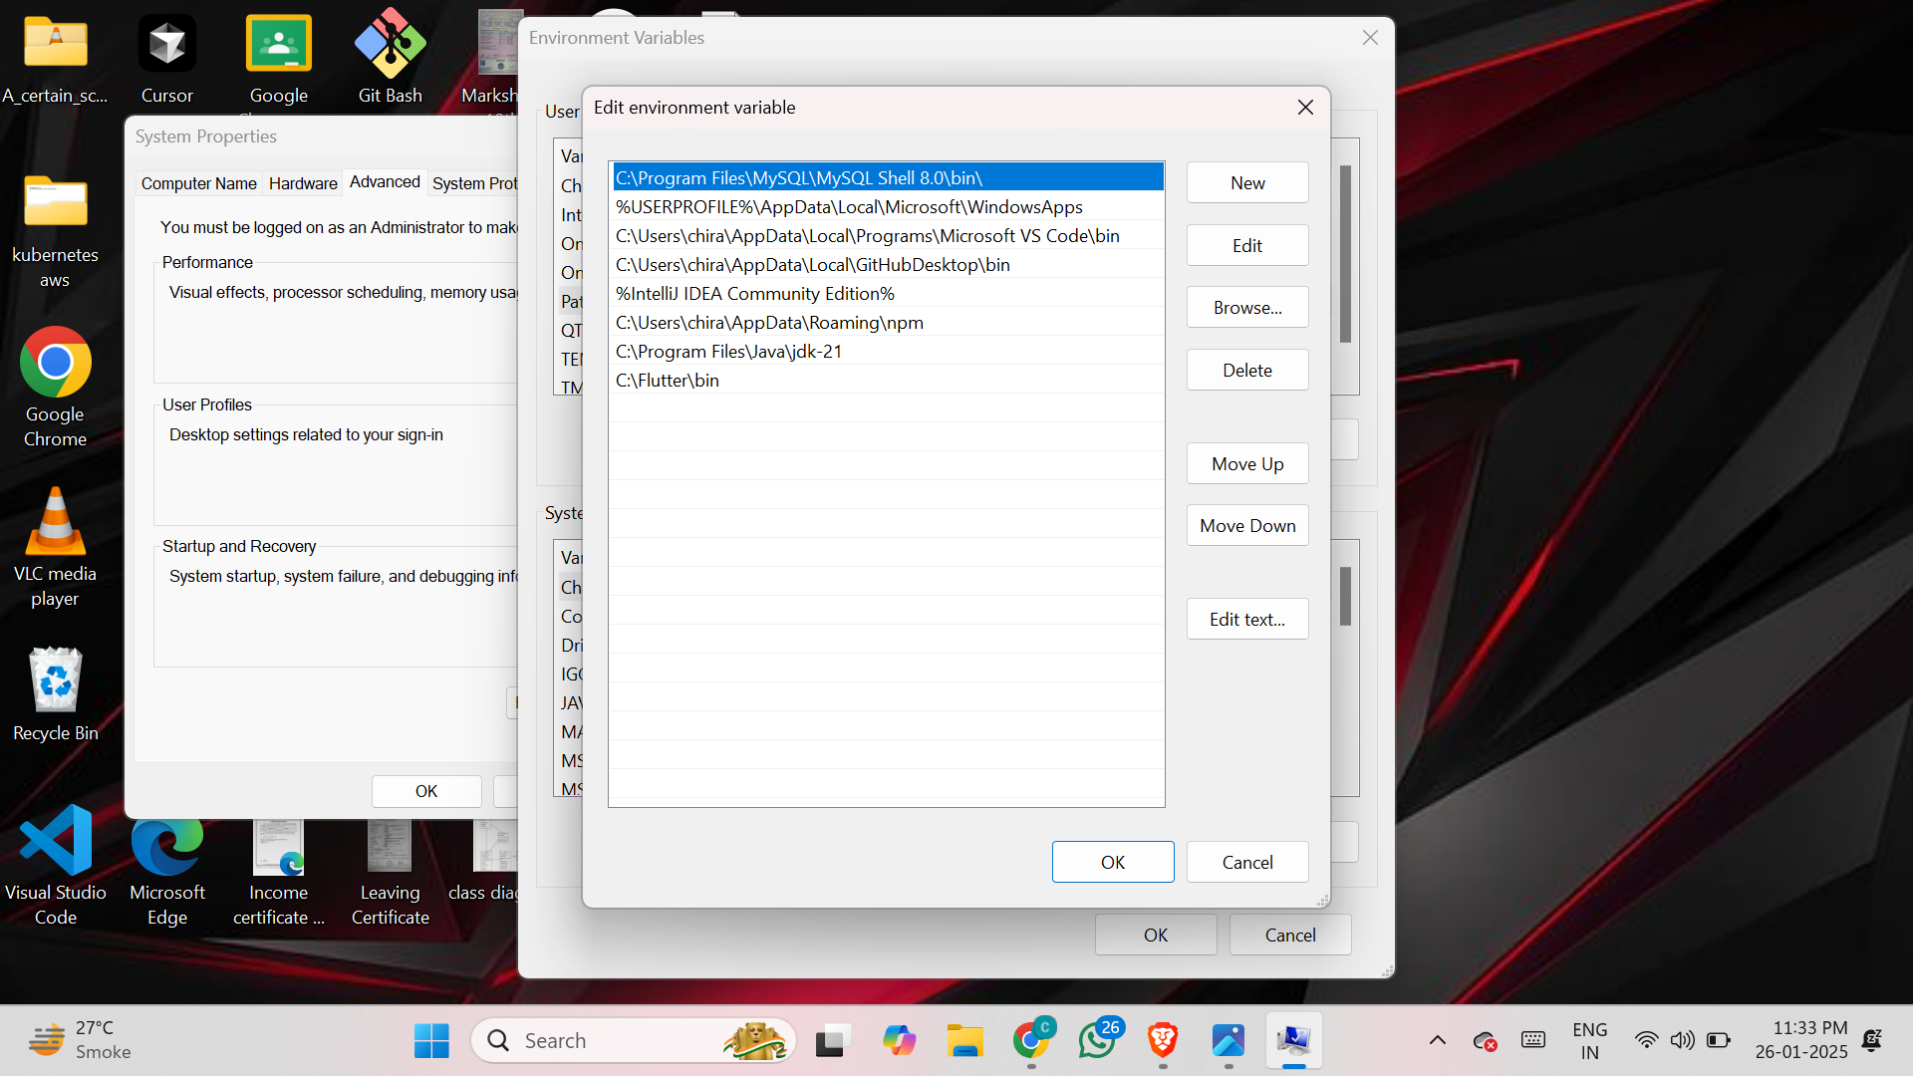

Step 6 : - Now, run the $ flutter command in command prompt

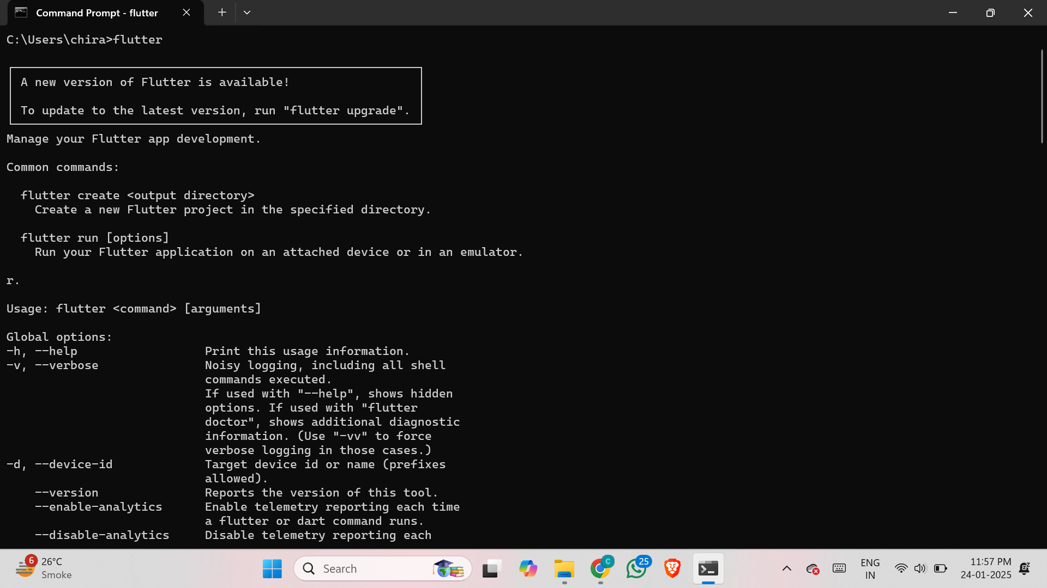

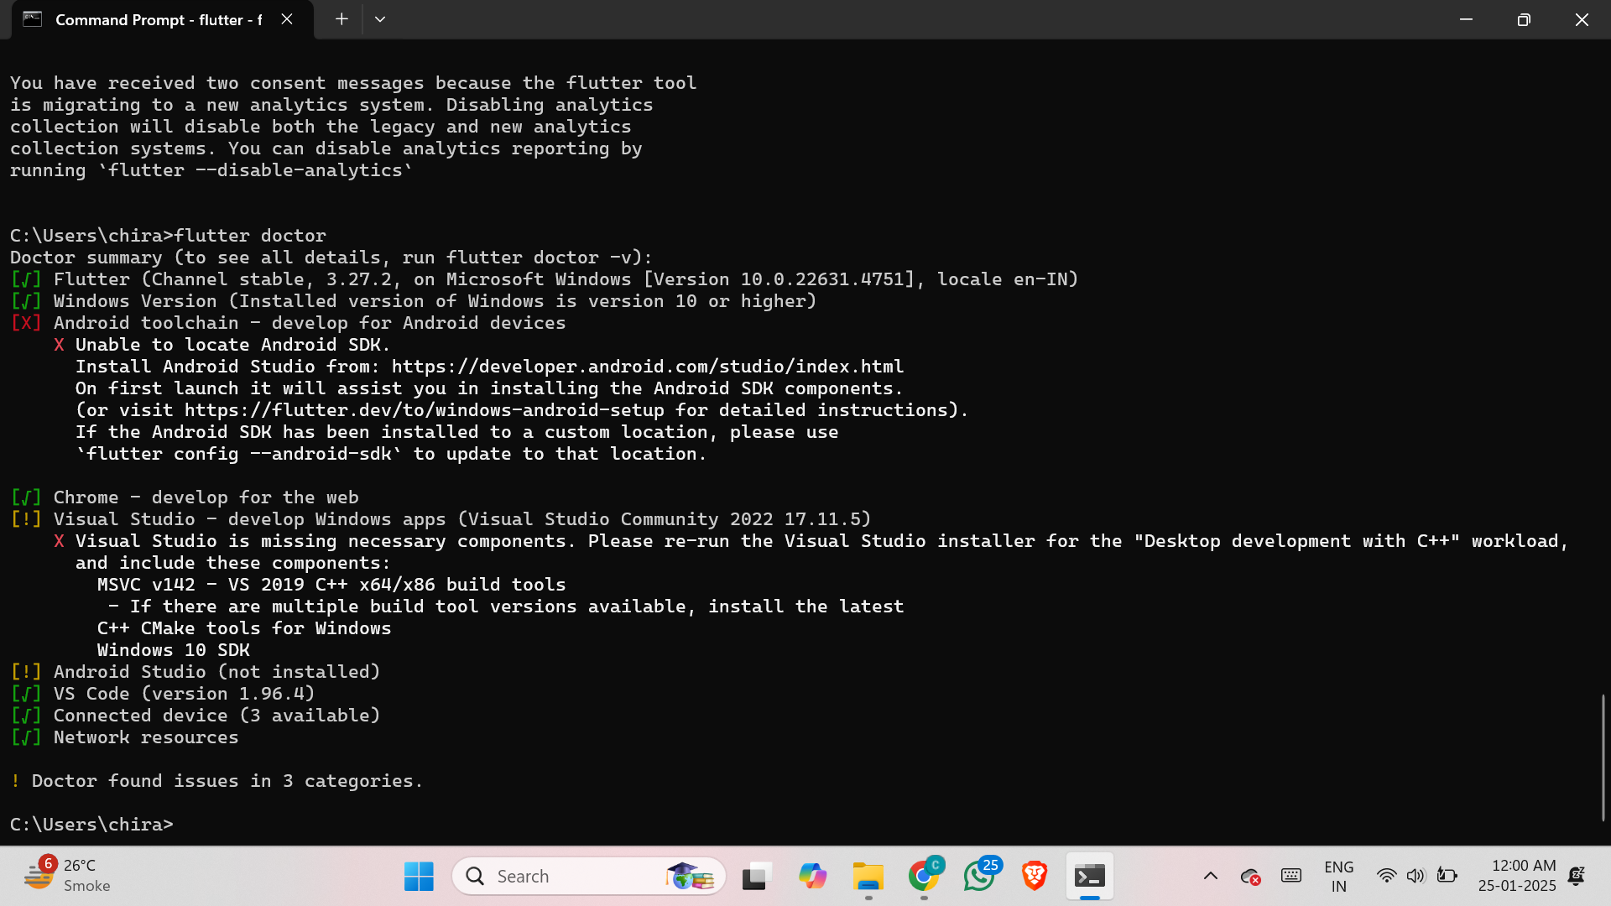

Step 7:- Run the $ flutter doctor command. This command checks for all the requirements of Flutter app development and displays a report of the status of your Flutter installation

Step 8 : - Go to Android Studio and download the installer

Step 8.1: - When the download is complete, open the .exe file and run it. You will get the following dialog box

Step 8.2: - Select all the Checkboxes and Click on ‘Next’ Button.

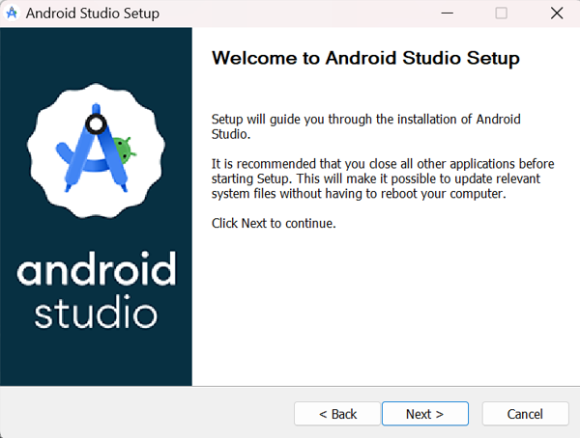

Step 8.3: - Change the destination as per your convenience and click on ‘Next’ Button.

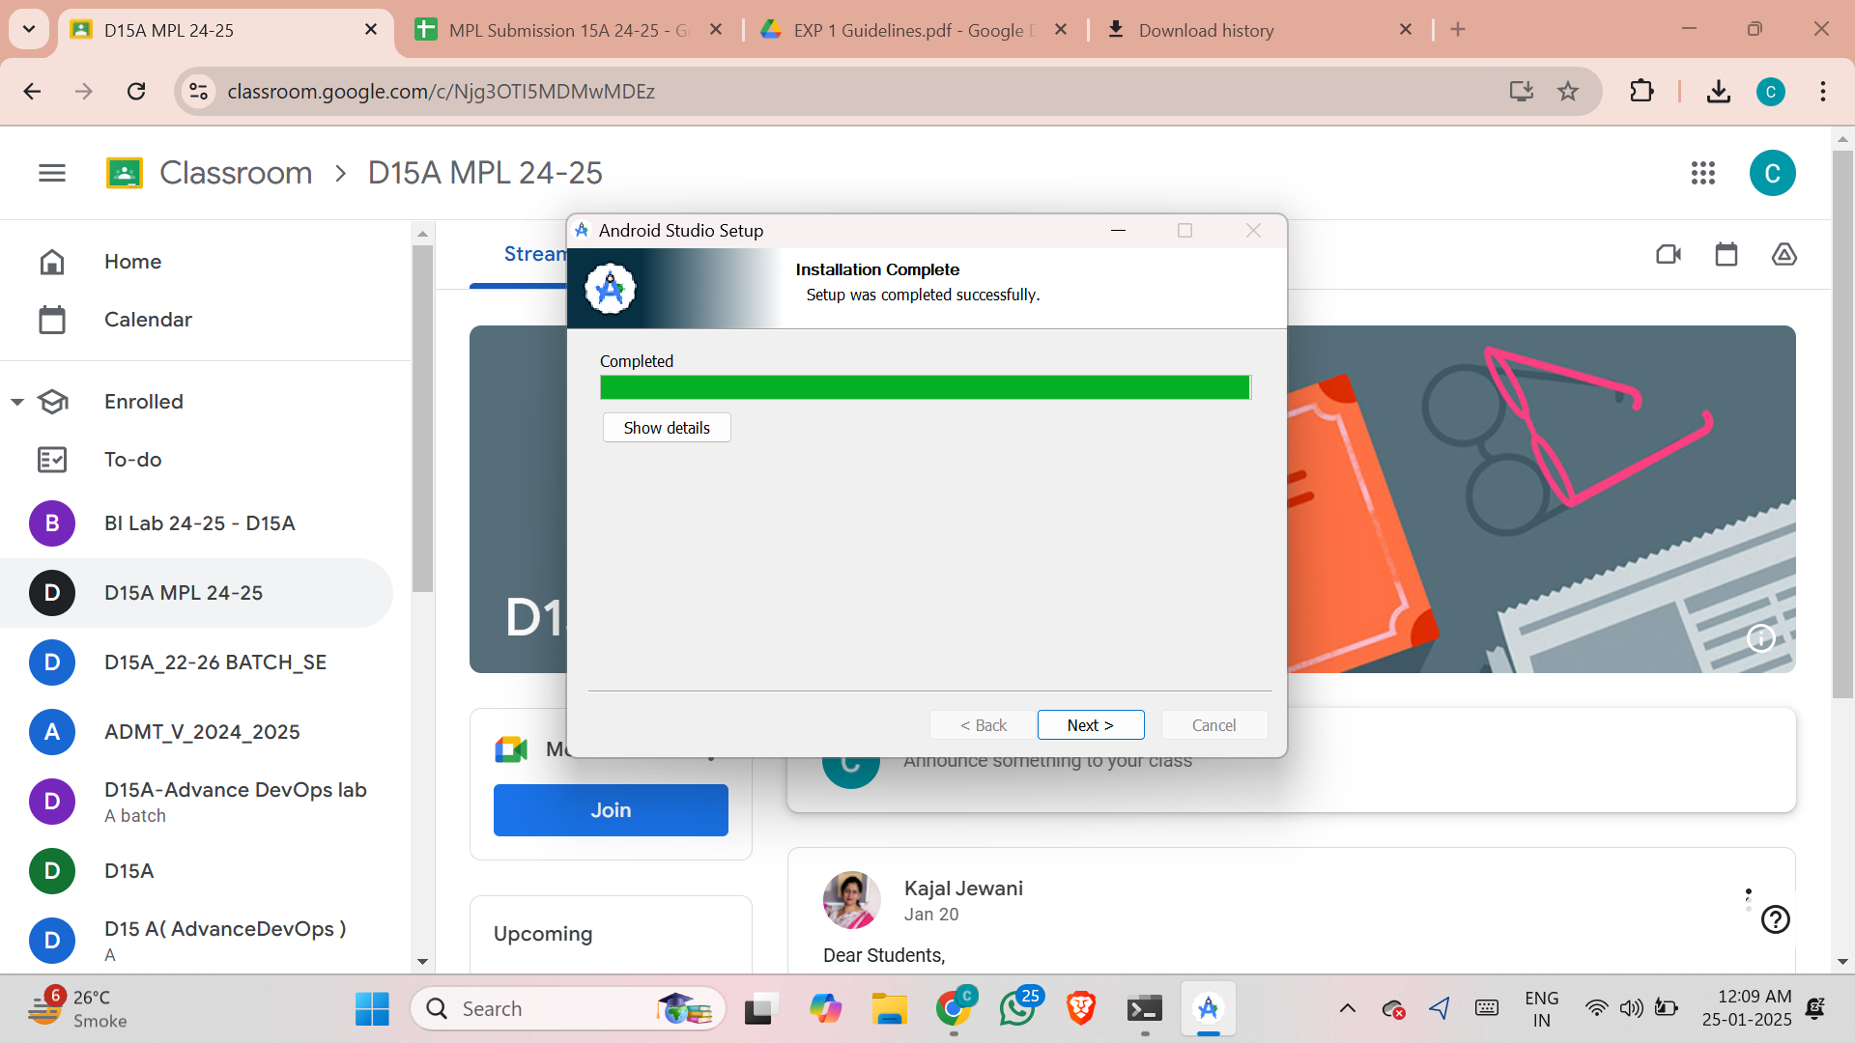

Step 8.4: - Follow the steps of the installation wizard. Once the installation wizard completes, you will get the following screen.

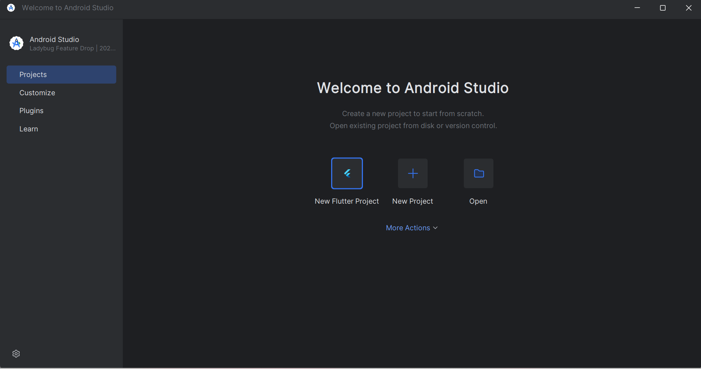

Step 8.5: - Go to Preferences > Appearance & Behavior > System Settings > Android SDK. Select the SDK Tools tab and check Android SDK Command-line Tools and Install it.

Step 9: - Open a terminal and run the following command

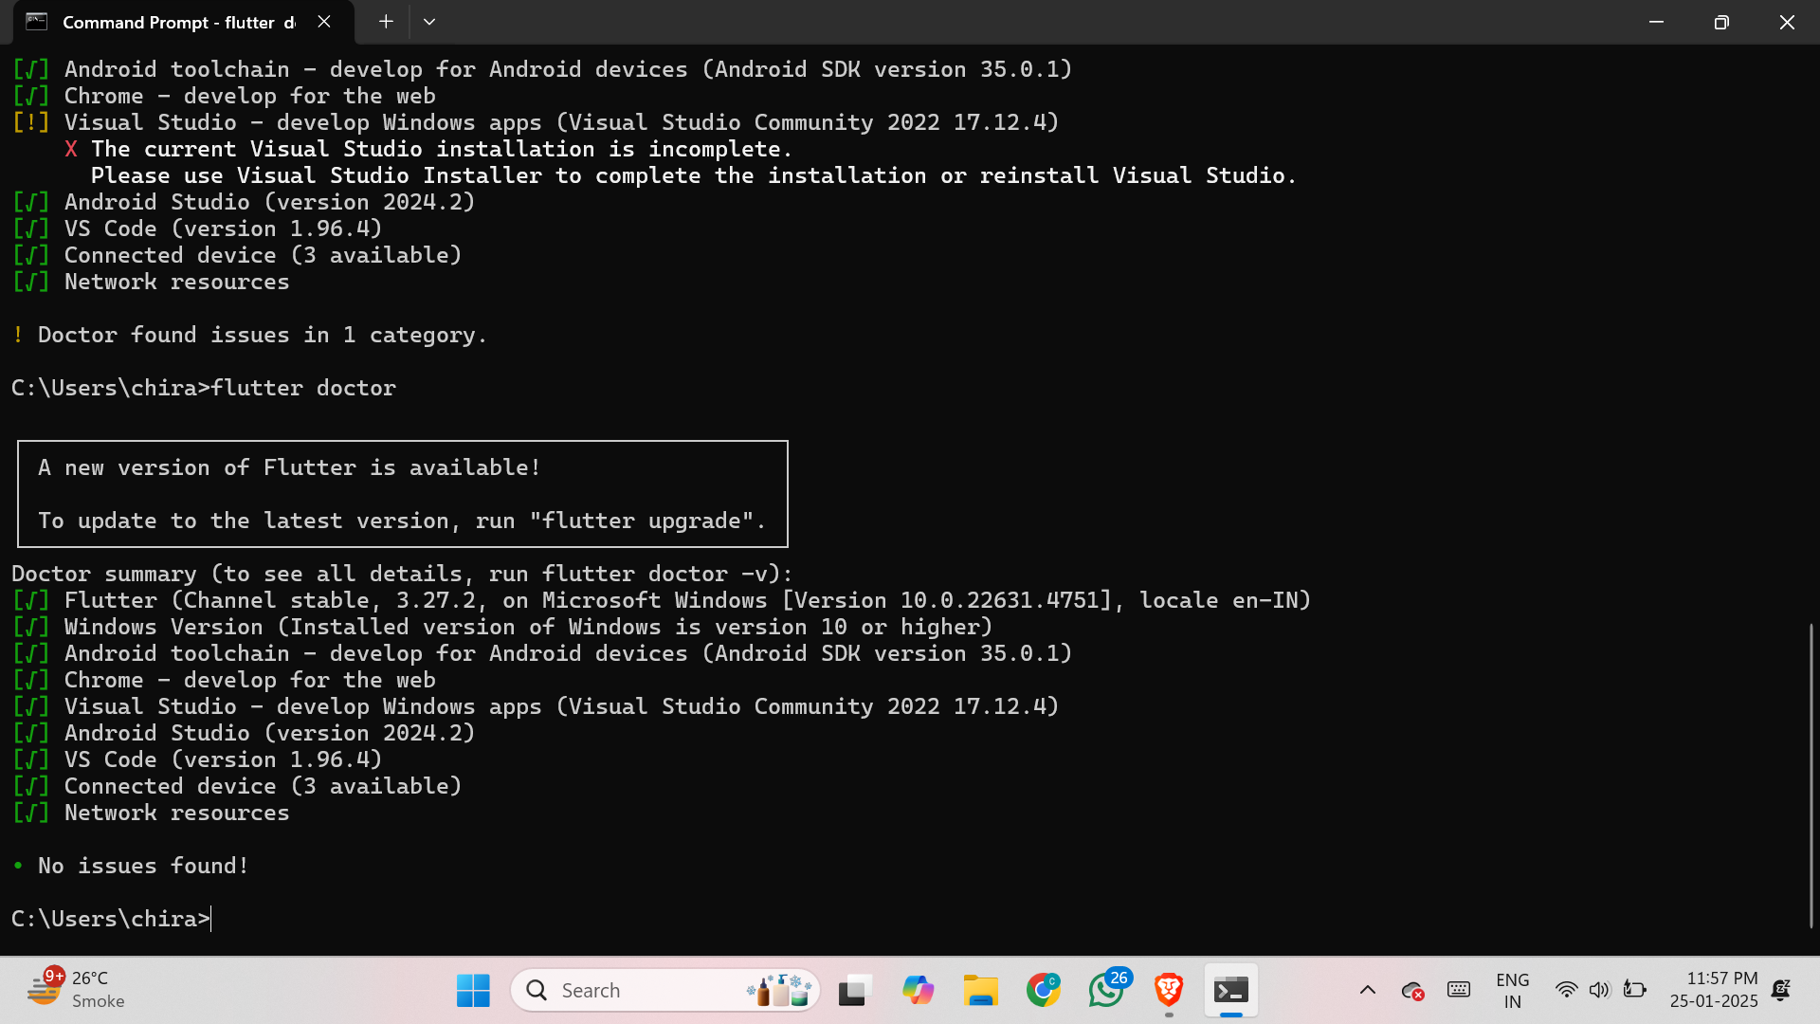

Step 10: - Next, you need to set up an Android emulator. It is responsible for running and testing the Flutter application

Step 10.1: - Open Android Studio and go to Tools > AVD Manager. Create a new virtual device.

Step 10.2: - Click on the icon pointed into the red color rectangle. The Android emulator displayed as below screen

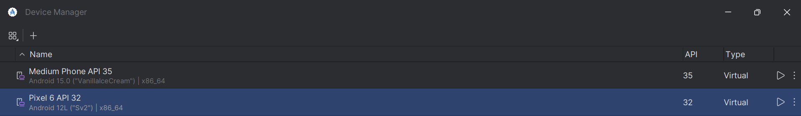

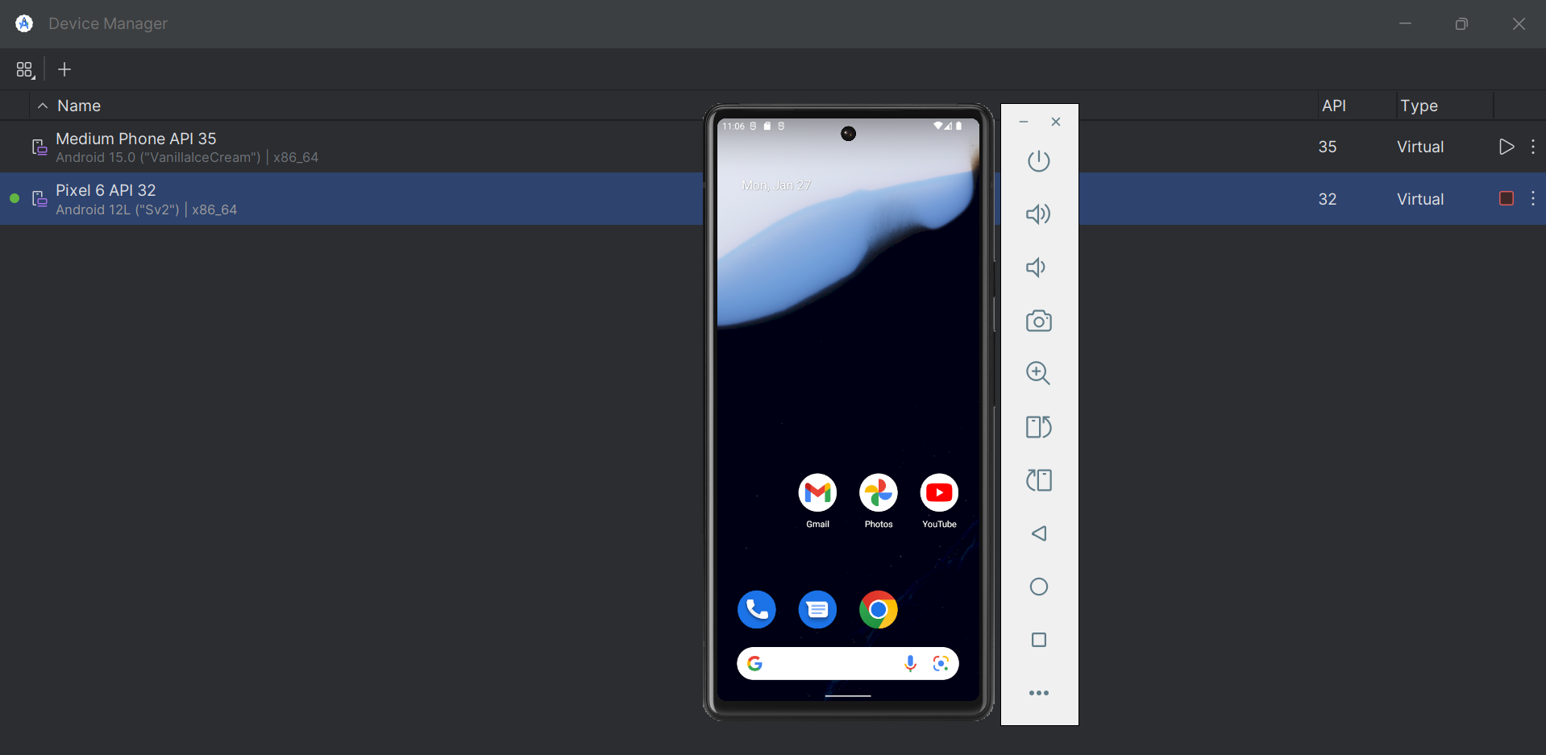

Step 11: - Now, install Flutter and Dart plugin for building Flutter application in Android Studio. These plugins provide a template to create a Flutter application, give an option to run and debug Flutter application in the Android Studio itself

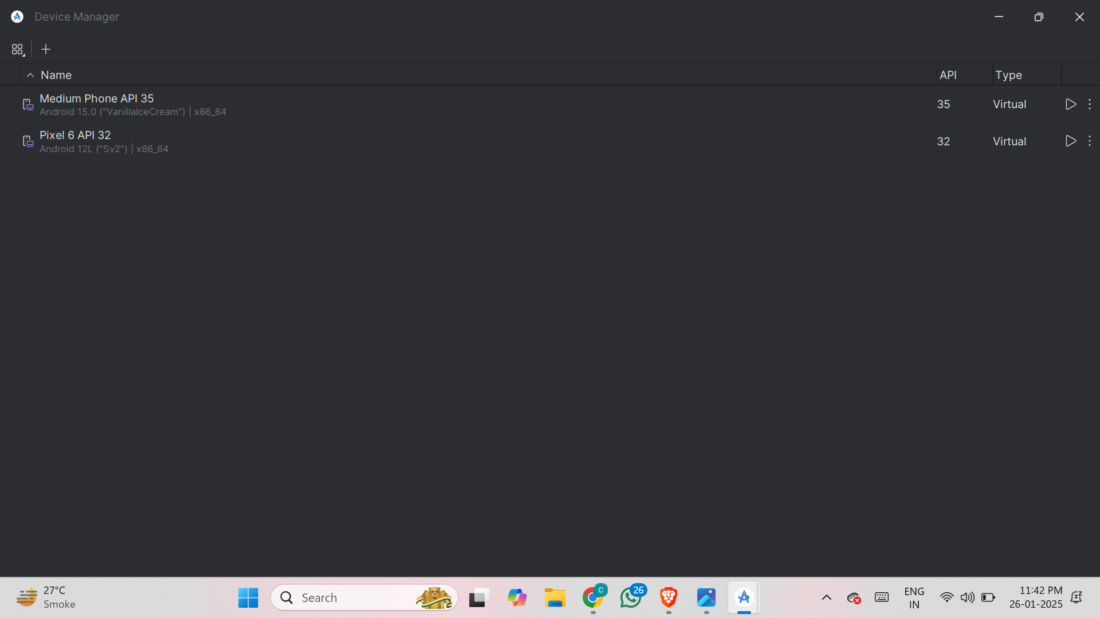

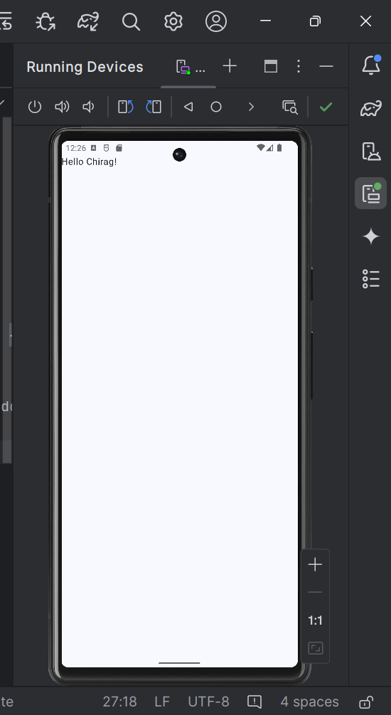

MAD & PWA Lab

Journal

|  |  |
| --- | --- |
| Experiment No. | 02 |
| Experiment Title. | To design Flutter UI by including common widgets. |
| Roll No. |  |
| Name | Chirag A Choudhary |
| Class | D15A |
| Subject | MAD & PWA Lab |
| Lab Outcome | LO2: Design and Develop interactive Flutter App by using widgets, layouts, gestures and animation |
| Grade: |  |

**Experiment 02**

**AIM:- To design Flutter UI by including common widgets.**

**Theory:-**

**CODE:-**

import 'package:flutter/material.dart';  
import 'login_screen.dart';  
import 'signup_screen.dart';  
  
class HomeScreen extends StatelessWidget {  
 @override  
 Widget build(BuildContext context) {  
 return Scaffold(  
 appBar: AppBar(  
 title: const Text('Home Page'),  
 backgroundColor: Colors.*blue*,  
 ),  
 body: Center(  
 child: Column(  
 mainAxisAlignment: MainAxisAlignment.center,  
 children: [  
 const Text(  
 'Welcome to Expense Tracker!',  
 style: TextStyle(fontSize: 22, fontWeight: FontWeight.*bold*),  
 textAlign: TextAlign.center,  
 ),  
 const SizedBox(height: 20),  
 ElevatedButton(  
 onPressed: () {  
 Navigator.*push*(  
 context,  
 MaterialPageRoute(builder: (context) => LoginScreen()),  
 );  
 },  
 child: const Text('Login'),  
 ),  
 const SizedBox(height: 10),  
 OutlinedButton(  
 onPressed: () {  
 Navigator.*push*(  
 context,  
 MaterialPageRoute(builder: (context) => SignupScreen()),  
 );  
 },  
 child: const Text('Sign Up'),  
 ),  
 ],  
 ),  
 ),  
 );  
 }  
}

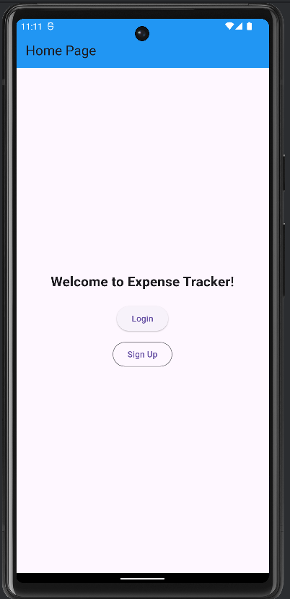

MAD & PWA Lab

Journal

|  |  |
| --- | --- |
| Experiment No. | 03 |
| Experiment Title. | To include icons, images, fonts in Flutter app |
| Roll No. |  |
| Name | Chirag A Choudhary |
| Class | D15A |
| Subject | MAD & PWA Lab |
| Lab Outcome | LO2: Design and Develop interactive Flutter App by using widgets, layouts, gestures and animation |
| Grade: |  |

# EXPERIMENT NO: - 03

**Name:-** Chirag Choudhary **Class:-** D15A **Roll:No: -** 10

**AIM: -** To include icons, images, fonts in Flutter app.

# Theory: -

Flutter is a versatile open-source UI framework , which allows developers to build natively compiled applications for mobile, web, and desktop platforms from a single codebase. One of the key strengths of Flutter is its flexibility in creating highly customizable UIs. This practical focuses on incorporating essential visual elements—icons, images, and custom fonts—into a Flutter application. These elements enhance the visual appeal and usability of the app, providing an engaging experience for users.

A flutter app when built has both assets (resources) and code. Assets are available and deployed during runtime. The asset is a file that can include static data, configuration files, icons, and images. The Flutter app supports many image formats, such as JPEG, WebP, PNG, GIF, animated WebP/GIF, BMP, and WBMP.

Visual elements play a significant role in app development.

* **Enhanced User Experience**: Images and icons make your app visually appealing and user- friendly.
* **Information Conveyance**: They convey information quickly and intuitively. A well- chosen icon can replace lengthy text.
* **Branding**: Custom icons and images reinforce your app's branding, making it memorable.

# Adding Icons in Flutter

Flutter provides built-in material design icons through the Icons class. Custom icons can also be added using third-party packages such as flutter_launcher_icons and font_awesome_flutter.

Icon( Icons.home, size: 40,

);

# Adding Images in Flutter

Flutter supports images from three sources:

* 1. **Assets** (Stored locally in the project)
     + Place the image inside the assets/images folder in the project.
     + Declare the image in pubspec.yaml

flutter:

assets:

- assets/images/sample.png

* + - Display the image in the app Image.asset('assets/images/sample.png');
  1. **Network** (Fetched from the internet)

Displaying images from the internet or network is very simple. Flutter provides a built-in method Image.network to work with images from a URL. The Image.network method also allows you to use some optional properties, such as height, width, color, fit, and many more.

Image.network('https://example.com/sample.jpg');

* 1. **Memory or File** (Stored on the device)

# Adding Custom Fonts in Flutter

By default, Flutter uses the Roboto font, but custom fonts can be added for a unique UI.

* Download the font and place it in the assets/fonts/ folder.
* Declare the font in pubspec.yaml
* Use the font in the app Text(

'Custom Font Example',

style: TextStyle(fontFamily: 'CustomFont', fontSize: 24),

);

Code: -

**expense_item.dart**

// expense_item.dart

import 'package:flutter/material.dart';

class ExpenseItem extends StatelessWidget { final String category;

final String description; final double amount;

const ExpenseItem({ Key? key,

required this.category, required this.description, required this.amount,

}) : super(key: key);

@override

Widget build(BuildContext context) { return Card(

margin: const EdgeInsets.symmetric(horizontal: 16, vertical: 8),

child: ListTile(

title: Text(category), subtitle: Text(description), trailing:

Text('₹${amount.toStringAsFixed(2)}'),

),

);

}

}

**custom_button.dart**

import 'package:flutter/material.dart';

class CustomButton extends StatelessWidget { final String label;

final VoidCallback onPressed;

@override

Widget build(BuildContext context) { return ElevatedButton(

onPressed: onPressed, child: Text(label),

);

CustomButton({required this.label, required }

this.onPressed}); }

# app_theme.dart

import 'package:flutter/material.dart';

class AppTheme {

static ThemeData get *lightTheme* { return ThemeData( primarySwatch: Colors.*blue*, appBarTheme: AppBarTheme(

backgroundColor: Colors.*blue*, elevation: 4,

),

buttonTheme: ButtonThemeData( buttonColor: Colors.*blue*,

textTheme: ButtonTextTheme.primary,

),

);

}

}

# pubspec.yaml

name: expense_tracker

description: A simple expense tracker app with authentication. publish_to: 'none' *# Prevents accidental publishing*

environment:

sdk: '>=3.0.0 <4.0.0' *# Update according to your Flutter SDK*

dependencies:

flutter:

sdk: flutter

*# firebase_core: ^2.24.2 # firebase_auth: ^4.15.3 # cloud_firestore: ^4.15.3*

dev_dependencies: flutter_test:

sdk: flutter

flutter:

uses-material-design: true

assets:

- assets/images/finance.png

**OUTPUT: -**

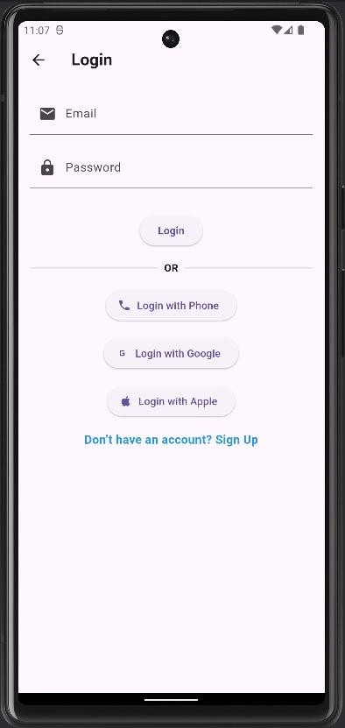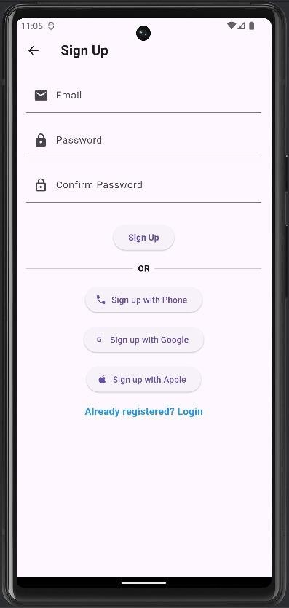

MAD & PWA Lab

Journal

|  |  |
| --- | --- |
| Experiment No. | 04 |
| Experiment Title. | To create an interactive Form using form widget |
| Roll No. | 10 |
| Name | Chirag A Choudhary |
| Class | D15A |
| Subject | MAD & PWA Lab |
| Lab Outcome | LO2: Design and Develop interactive Flutter App by using widgets, layouts, gestures and animation |
| Grade: |  |

**Exp 4**

**AIM:- To create an interactive Form using form widget**

**Theory:-**

**Code:-**

**signup_screen.dart**

import 'package:flutter/material.dart';  
import 'expenses_screen.dart';  
import 'login_screen.dart';  
  
class SignupScreen extends StatefulWidget {  
 @override  
 _SignupScreenState createState() => _SignupScreenState();  
}  
  
class _SignupScreenState extends State<SignupScreen> {  
 final _formKey = GlobalKey<FormState>();  
 final _emailController = TextEditingController();  
 final _passwordController = TextEditingController();  
 final _confirmPasswordController = TextEditingController();  
 String _errorMessage = '';  
  
 void _signup() {  
 if (_formKey.currentState!.validate()) {  
 if (_passwordController.text != _confirmPasswordController.text) {  
 setState(() {  
 _errorMessage = 'Passwords do not match';  
 });  
 return;  
 }  
  
 // Simulate successful signup  
 Navigator.*pushReplacement*(  
 context,  
 MaterialPageRoute(builder: (context) => ExpensesScreen()),  
 );  
 }  
 }  
  
 @override  
 Widget build(BuildContext context) {  
 return Scaffold(  
 appBar: AppBar(title: Text('Sign Up', style: TextStyle(fontWeight: FontWeight.*bold*))),  
 body: Padding(  
 padding: EdgeInsets.all(16.0),  
 child: Form(  
 key: _formKey,  
 child: Column(  
 children: [  
 TextFormField(  
 controller: _emailController,  
 decoration: InputDecoration(  
 labelText: 'Email',  
 prefixIcon: Icon(Icons.*email*),  
 ),  
 validator: (value) => value!.isEmpty ? 'Enter email' : null,  
 ),  
 SizedBox(height: 16),  
 TextFormField(  
 controller: _passwordController,  
 obscureText: true,  
 decoration: InputDecoration(  
 labelText: 'Password',  
 prefixIcon: Icon(Icons.*lock*),  
 ),  
 validator: (value) => value!.length < 6 ? 'Min 6 chars' : null,  
 ),  
 SizedBox(height: 16),  
 TextFormField(  
 controller: _confirmPasswordController,  
 obscureText: true,  
 decoration: InputDecoration(  
 labelText: 'Confirm Password',  
 prefixIcon: Icon(Icons.*lock_outline*),  
 ),  
 validator: (value) => value!.isEmpty ? 'Confirm password' : null,  
 ),  
 SizedBox(height: 16),  
 if (_errorMessage.isNotEmpty)  
 Text(_errorMessage, style: TextStyle(color: Colors.*red*, fontWeight: FontWeight.*bold*)),  
 SizedBox(height: 16),  
 ElevatedButton(  
 onPressed: _signup,  
 child: Text('Sign Up', style: TextStyle(fontWeight: FontWeight.*bold*)),  
 ),  
 SizedBox(height: 16),  
 Row(  
 children: [  
 Expanded(child: Divider(thickness: 1)),  
 Padding(  
 padding: EdgeInsets.symmetric(horizontal: 8.0),  
 child: Text('OR', style: TextStyle(fontWeight: FontWeight.*bold*)),  
 ),  
 Expanded(child: Divider(thickness: 1)),  
 ],  
 ),  
 SizedBox(height: 16),  
 ElevatedButton.icon(  
 onPressed: () {},  
 icon: Icon(Icons.*phone*),  
 label: Text('Sign up with Phone'),  
 ),  
 SizedBox(height: 16),  
 ElevatedButton.icon(  
 onPressed: () {},  
 icon: Icon(Icons.*g_mobiledata*),  
 label: Text('Sign up with Google'),  
 ),  
 SizedBox(height: 16),  
 ElevatedButton.icon(  
 onPressed: () {},  
 icon: Icon(Icons.*apple*),  
 label: Text('Sign up with Apple'),  
 ),  
 SizedBox(height: 16),  
 GestureDetector(  
 onTap: () {  
 Navigator.*pushReplacement*(  
 context,  
 MaterialPageRoute(builder: (context) => LoginScreen()),  
 );  
 },  
 child: Text(  
 'Already registered? Login',  
 style: TextStyle(fontSize: 16, fontWeight: FontWeight.*bold*, color: Colors.*blue*),  
 ),  
 ),  
 ],  
 ),  
 ),  
 ),  
 );  
 }  
}

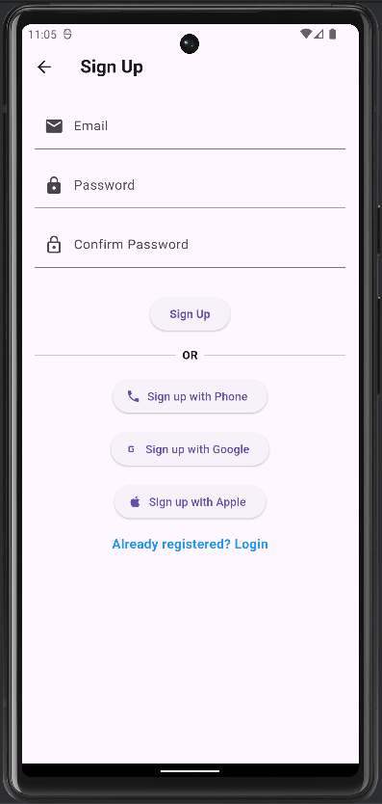

**login_screen:-**

import 'package:flutter/material.dart';  
import 'expenses_screen.dart';  
import 'signup_screen.dart';  
  
class LoginScreen extends StatefulWidget {  
 @override  
 _LoginScreenState createState() => _LoginScreenState();  
}  
  
class _LoginScreenState extends State<LoginScreen> {  
 final _formKey = GlobalKey<FormState>();  
 final _emailController = TextEditingController();  
 final _passwordController = TextEditingController();  
 String _errorMessage = '';  
  
 void _login() {  
 if (_formKey.currentState!.validate()) {  
 // Simulate successful login  
 Navigator.*pushReplacement*(  
 context,  
 MaterialPageRoute(builder: (context) => ExpensesScreen()),  
 );  
 }  
 }  
  
 @override  
 Widget build(BuildContext context) {  
 return Scaffold(  
 appBar: AppBar(title: Text('Login', style: TextStyle(fontWeight: FontWeight.*bold*))),  
 body: Padding(  
 padding: EdgeInsets.all(16.0),  
 child: Form(  
 key: _formKey,  
 child: Column(  
 children: [  
 TextFormField(  
 controller: _emailController,  
 decoration: InputDecoration(  
 labelText: 'Email',  
 prefixIcon: Icon(Icons.*email*),  
 ),  
 validator: (value) => value!.isEmpty ? 'Enter email' : null,  
 ),  
 SizedBox(height: 16),  
 TextFormField(  
 controller: _passwordController,  
 obscureText: true,  
 decoration: InputDecoration(  
 labelText: 'Password',  
 prefixIcon: Icon(Icons.*lock*),  
 ),  
 validator: (value) => value!.length < 6 ? 'Min 6 chars' : null,  
 ),  
 SizedBox(height: 16),  
 if (_errorMessage.isNotEmpty)  
 Text(_errorMessage, style: TextStyle(color: Colors.*red*, fontWeight: FontWeight.*bold*)),  
 SizedBox(height: 16),  
 ElevatedButton(  
 onPressed: _login,  
 child: Text('Login', style: TextStyle(fontWeight: FontWeight.*bold*)),  
 ),  
 SizedBox(height: 16),  
 Row(  
 children: [  
 Expanded(child: Divider(thickness: 1)),  
 Padding(  
 padding: EdgeInsets.symmetric(horizontal: 8.0),  
 child: Text('OR', style: TextStyle(fontWeight: FontWeight.*bold*)),  
 ),  
 Expanded(child: Divider(thickness: 1)),  
 ],  
 ),  
 SizedBox(height: 16),  
 ElevatedButton.icon(  
 onPressed: () {},  
 icon: Icon(Icons.*phone*),  
 label: Text('Login with Phone'),  
 ),  
 SizedBox(height: 16),  
 ElevatedButton.icon(  
 onPressed: () {},  
 icon: Icon(Icons.*g_mobiledata*),  
 label: Text('Login with Google'),  
 ),  
 SizedBox(height: 16),  
 ElevatedButton.icon(  
 onPressed: () {},  
 icon: Icon(Icons.*apple*),  
 label: Text('Login with Apple'),  
 ),  
 SizedBox(height: 16),  
 GestureDetector(  
 onTap: () {  
 Navigator.*pushReplacement*(  
 context,  
 MaterialPageRoute(builder: (context) => SignupScreen()),  
 );  
 },  
 child: Text(  
 'Don’t have an account? Sign Up',  
 style: TextStyle(fontSize: 16, fontWeight: FontWeight.*bold*, color: Colors.*blue*),  
 ),  
 ),  
 ],  
 ),  
 ),  
 ),  
 );  
 }  
}

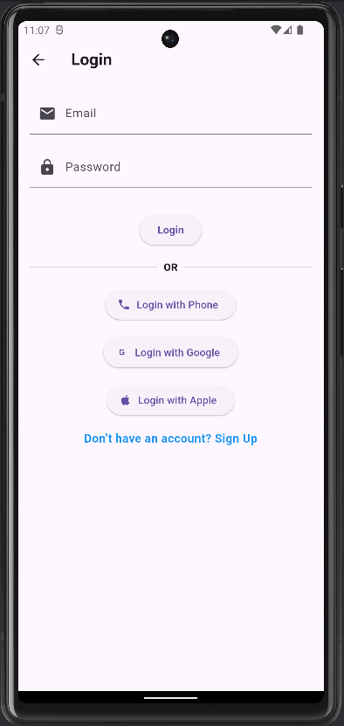

MAD & PWA Lab

Journal

|  |  |
| --- | --- |
| Experiment No. | 05 |
| Experiment Title. | To apply navigation, routing and gestures in Flutter App |
| Roll No. | 10 |
| Name | Chirag A Choudhary |
| Class | D15A |
| Subject | MAD & PWA Lab |
| Lab Outcome | LO2: Design and Develop interactive Flutter App by using widgets, layouts, gestures and animation |
| Grade: |  |

# EXPERIMENT 5

**AIM:** To implement navigation, routing, and gestures in a Flutter-based Expense Tracker app.

## THEORY:

In Flutter, building interactive and multi-screen applications involves the use of navigation, routing, and gesture handling. These features are essential for creating user-friendly, responsive, and intuitive mobile applications.  
  
Navigation refers to the ability to move between different screens in an app. Flutter uses a stack-based system, where new pages are pushed onto the stack and removed when the user navigates back.  
  
Routing defines how screens are organized and navigated between. There are two common types of routing in Flutter:  
- Basic Routing using MaterialPageRoute  
- Named Routing for structured navigation  
  
Gestures are user interactions such as taps, swipes, or long-presses. Flutter provides widgets like GestureDetector to detect and respond to these inputs.  
  
In the Expense Tracker app, navigation allows the user to log in and move to the home screen, view and add expenses, while gestures enable interactive elements like tapping an expense to view details.

## CODE SNIPPETS:

### Navigation: Login to Home

Navigator.pushReplacement(  
 context,  
 MaterialPageRoute(builder: (context) => HomeScreen()),  
);

### Routing: Home to Add Expense

FloatingActionButton(  
 onPressed: () {  
 Navigator.push(  
 context,  
 MaterialPageRoute(builder: (context) => AddExpenseScreen()),  
 );  
 },  
 child: Icon(Icons.add),  
);

### Gesture: Tap to Show Details

GestureDetector(  
 onTap: () {  
 showDialog(  
 context: context,  
 builder: (context) => AlertDialog(  
 title: Text("Expense Details"),  
 content: Text("Amount: ₹500  
Category: Food"),  
 ),  
 );  
 },  
 child: ExpenseCard(),  
);

## OUTPUT:

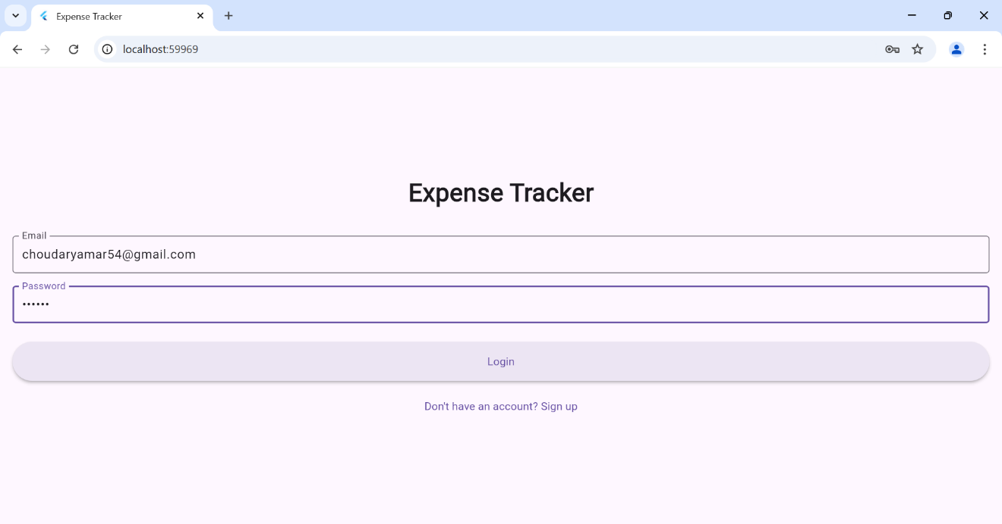

• User taps 'Login' → Home Screen opens.

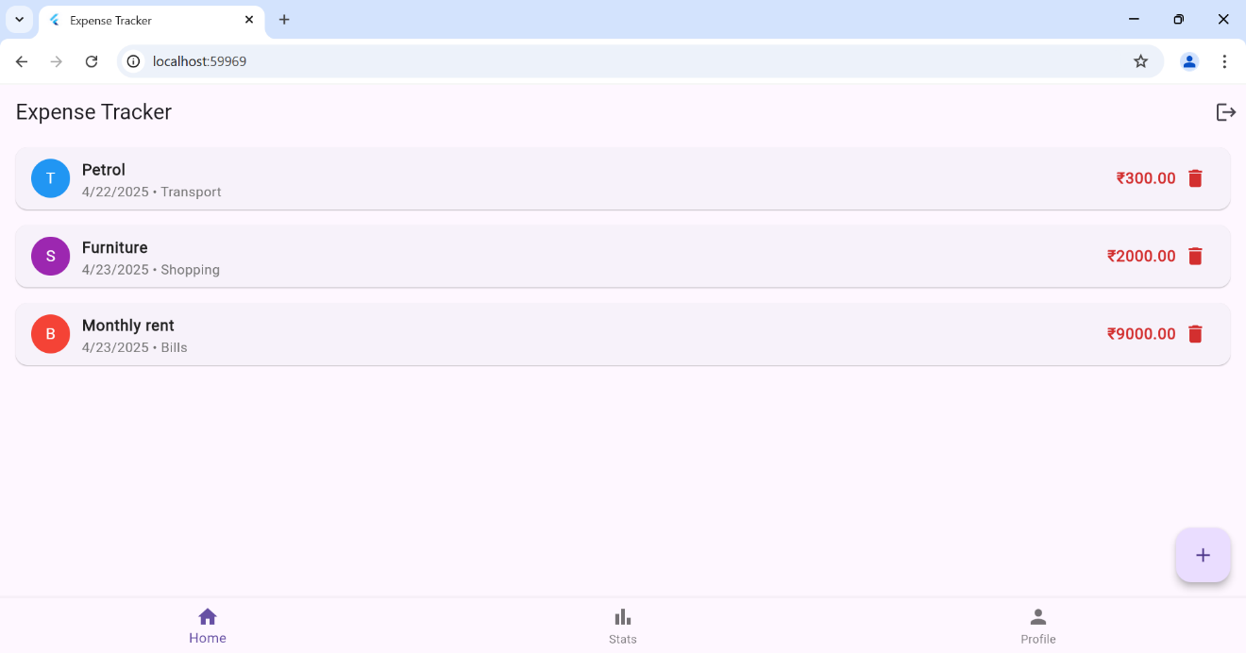

• User taps '+' button → Add Expense screen is shown.

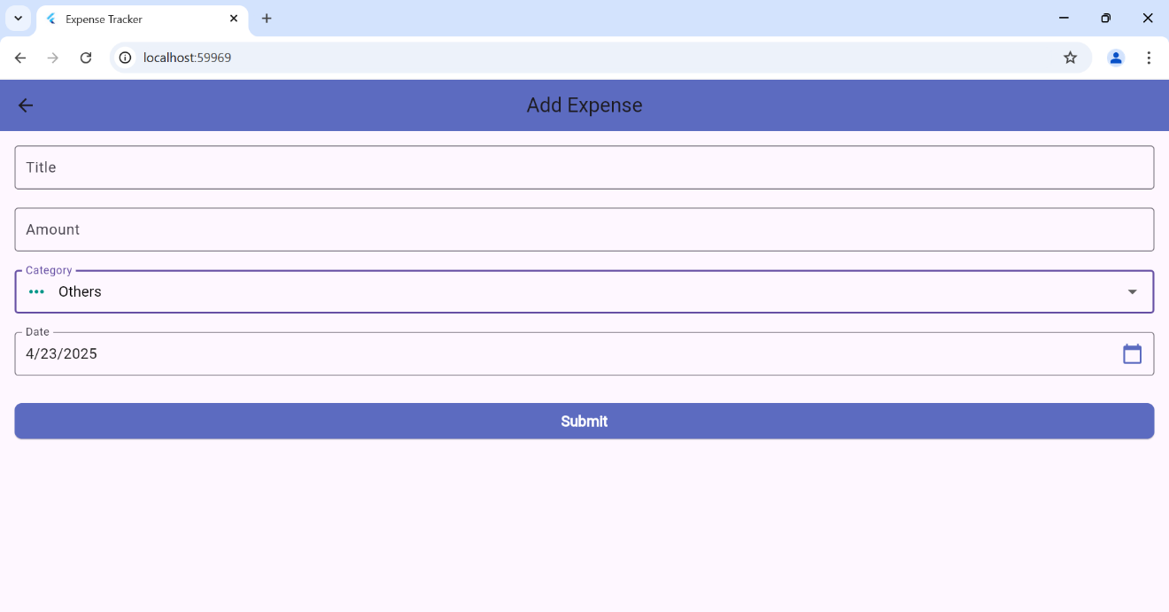

User taps on the "Stats" tab → A pie chart is displayed showing expense distribution by category.

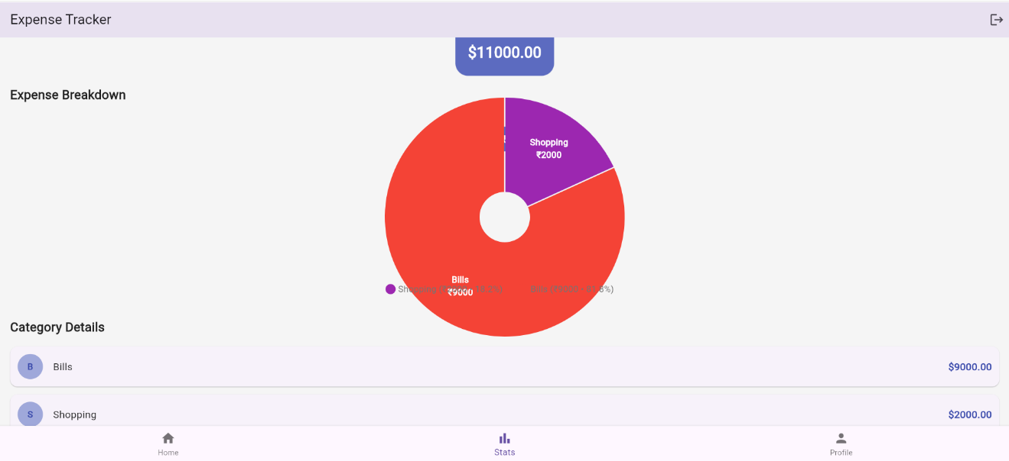

## CONCLUSION:

This experiment demonstrated how to implement navigation, routing, and gestures in a Flutter app. In the Expense Tracker app, these features help users move between screens and interact with the UI efficiently, improving the app’s overall usability and user experience.

MAD & PWA Lab

Journal

|  |  |
| --- | --- |
| Experiment No. | 06 |
| Experiment Title. | To Connect Flutter UI with fireBase database |
| Roll No. | 10 |
| Name | Chirag A Choudhary |
| Class | D15A |
| Subject | MAD & PWA Lab |
| Lab Outcome | LO3: Analyze and Build production ready Flutter App by incorporating backend services and deploying on Android / iOS |
| Grade: |  |

# EXPERIMENT 6

**AIM:** To connect a Flutter-based Expense Tracker UI with Firebase for user authentication and expense data storage.

## THEORY:

Firebase is a comprehensive backend-as-a-service (BaaS) platform developed by Google. It provides a wide range of tools and services such as authentication, real-time databases, cloud storage, and analytics to help developers build and scale modern mobile and web applications.  
  
Integrating Firebase with Flutter allows developers to enhance their apps with powerful backend capabilities while focusing on building rich user interfaces using Flutter.  
  
Why Use Firebase with Flutter?  
- Real-time Functionality: Firebase offers real-time database and cloud-based data synchronization, making it ideal for dynamic data apps like Expense Trackers.  
- User Authentication: Secure sign-in and sign-up using email/password or social providers.  
- Data Storage: Store structured expense data in Firestore.  
- Notifications: Send push notifications using Firebase Cloud Messaging (if needed).  
- Analytics & Crash Reporting: Monitor user behavior and app performance in real-time.  
  
Common Firebase Services Used:  
- Firebase Authentication: For managing user login and identity verification.  
- Cloud Firestore: A scalable NoSQL database used to store and sync expenses.  
- Firebase Storage: (Optional) For uploading receipts or images.  
- Firebase Cloud Messaging: (Optional) For sending reminders.  
  
Benefits of Using Firebase with Flutter:  
- Cross-Platform Support  
- Scalability  
- Built-in Security Rules  
- Faster Development

## CODE SNIPPETS:

### main.dart:

void main() async {  
 WidgetsFlutterBinding.ensureInitialized();  
 await Firebase.initializeApp();  
 runApp(const MyApp());  
}

### auth_provider.dart:

Future<void> login(String email, String password) async {  
 final credential = await FirebaseAuth.instance.signInWithEmailAndPassword(  
 email: email,  
 password: password,  
 );  
 user = credential.user;  
 notifyListeners();  
}

### login_screen.dart:

ElevatedButton(  
 onPressed: login,  
 child: const Text("Login"),  
)

### Firestore Usage in expense_provider.dart (if applicable):

FirebaseFirestore.instance.collection('expenses').add({  
 'amount': expense.amount,  
 'category': expense.category,  
 'date': expense.date.toIso8601String(),  
 'userId': user.uid,  
});

### build.gradle:

dependencies {  
 implementation platform('com.google.firebase:firebase-bom:33.9.0')  
 implementation 'com.google.firebase:firebase-auth'  
 implementation 'com.google.firebase:firebase-firestore'  
}

## OUTPUT:

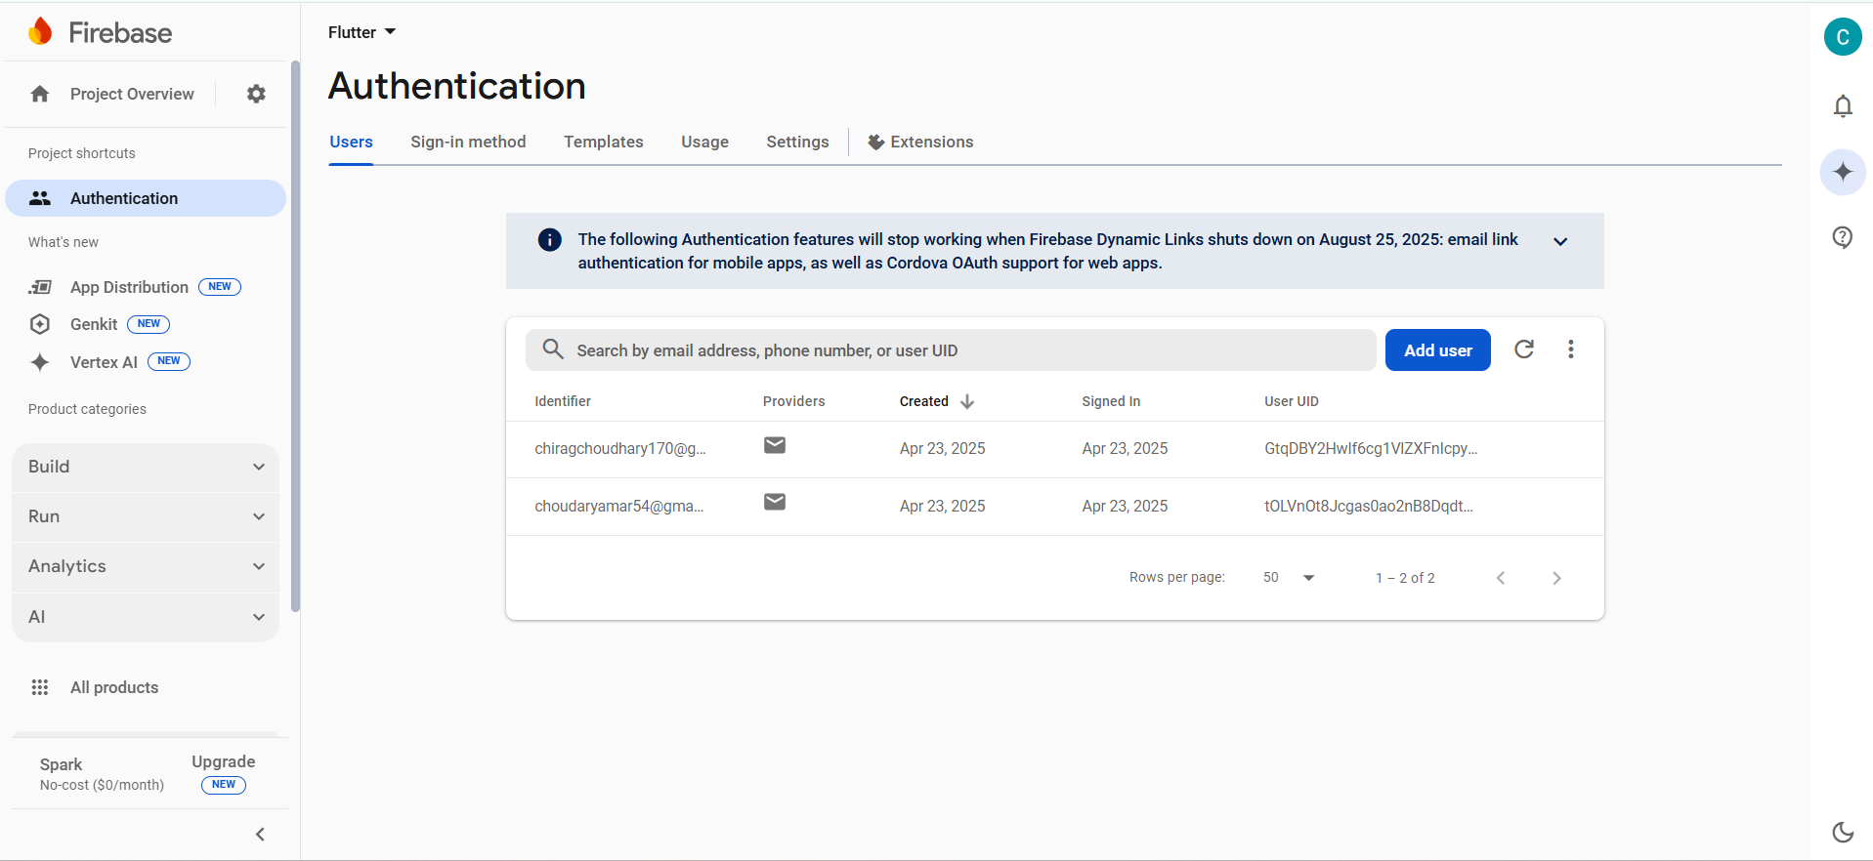

## CONCLUSION:

Integrating Firebase with Flutter enabled secure login and real-time data storage in the Expense Tracker app. The Firebase Auth SDK handled user sessions, while Firestore was used to store and retrieve categorized expenses per user.

MAD & PWA Lab

Journal

|  |  |
| --- | --- |
| Experiment No. | 07 |
| Experiment Title. | To write meta data of your Ecommerce PWA in a Web app manifest file to enable “add to homescreen feature”. |
| Roll No. | 10 |
| Name | Chirag A Choudhary |
| Class | D15A |
| Subject | MAD & PWA Lab |
| Lab Outcome | LO4: Understand various PWA frameworks and their requirements |
| Grade: |  |

**Experiment No. 7**

**Name:- Chirag Choudhary Roll No:- 10**

**Aim:-** To write meta data of your PWA in a Web app manifest file to enable “add to homescreen feature”.

**Theory:-**

Regular Web App

A regular web app is a website that is designed to be accessible on all mobile devices such that the content gets fit as per the device screen. It is designed using a web technology stack (HTML, CSS, JavaScript, Ruby, etc.) and operates via a browser. They offer various native-device features and functionalities. However, it entirely depends on the browser the user is using. In other words, it might be possible that you can access a native-device feature on Chrome but not on Safari or Mozilla Firefox because the browsers are incompatible with that feature.

Progressive Web App

Progressive Web App (PWA) is a regular web app, but some extras enable it to deliver an excellent user experience. It is a perfect blend of desktop and mobile application experience to give both platforms to the end-users.

Difference between PWAs vs. Regular Web Apps:

A Progressive Web is different and better than a Regular Web app with features like:

1. Native Experience

Though a PWA runs on web technologies (HTML, CSS, JavaScript) like a Regular web app, it gives user experience like a native mobile application. It can use most native device features, including push notifications, without relying on the browser or any other entity. It offers a seamless and integrated user experience that it is quite tough for one to differentiate between a PWA and a Native application by considering its look and feel.

2. Ease of Access

Unlike other mobile apps, PWAs do not demand longer download time and make memory space available for installing the applications. The PWAs can be shared and installed by a link, which cuts down the number of steps to install and use. These applications can easily keep an app icon on the user's home screen, making the app easily accessible to the users and helps the brands remain in the users' minds, and improving the chances of interaction.

3. Faster Services

PWAs can cache the data and serve the user with text stylesheets, images, and other web content even before the page loads completely. This lowers the waiting time for the end-users and helps the brands improve the user engagement and retention rate, which eventually adds value to their business.

4. Engaging Approach

As already shared, the PWAs can employ push notifications and other native device features more efficiently. Their interaction does not depend on the browser user uses. This eventually improves the chances of notifying the user regarding your services, offers, and other options related to your brand and keeping them hooked to your brand. In simpler words, PWAs let you maintain the user engagement and retention rate.

5. Updated Real-Time Data Access

Another plus point of PWAs is that these apps get updated on their own. They do not demand the end-users to go to the App Store or other such platforms to download the update and wait until installed.

In this app type, the web app developers can push the live update from the server, which reaches the apps residing on the user's devices automatically. Therefore, it is easier for the mobile app developer to provide the best of the updated functionalities and services to the end-users without forcing them to update their app.

6. Discoverable

PWAs reside in web browsers. This implies higher chances of optimizing them as per the Search Engine Optimization (SEO) criteria and improving the Google rankings like that in websites and other web apps.

7. Lower Development Cost

Progressive web apps can be installed on the user device like a native device, but it does not demand submission on an App Store. This makes it far more cost-effective than native mobile applications while offering the same set of functionalities.

**Pros and cons of the Progressive Web App**

The main features are:

Progressive — They work for every user, regardless of the browser chosen because they are built at the base with progressive improvement principles.

Responsive — They adapt to the various screen sizes: desktop, mobile, tablet, or dimensions that can later become available.

App-like — They behave with the user as if they were native apps, in terms of interaction and navigation.

Updated — Information is always up-to-date thanks to the data update process offered by service workers.

Secure — Exposed over HTTPS protocol to prevent the connection from displaying information or altering the contents.

Searchable — They are identified as “applications” and are indexed by search engines.

Reactivable — Make it easy to reactivate the application thanks to capabilities such as web notifications.

Installable — They allow the user to “save” the apps that he considers most useful with the corresponding icon on the screen of his mobile terminal (home screen) without having to face all the steps and problems related to the use of the app store.

Linkable — Easily shared via URL without complex installations.

Offline — Once more it is about putting the user before everything, avoiding the usual error message in case of weak or no connection. The PWA are based on two particularities: first of all the ‘skeleton’ of the app, which recalls the page structure, even if its contents do not respond and its elements include the header, the page layout, as well as an illustration that signals that the page is loading.

Weaknesses refer to:

IOS support from version 11.3 onwards;

Greater use of the device battery;

Not all devices support the full range of PWA features (same speech for iOS and Android operating systems);

It is not possible to establish a strong re-engagement for iOS users (URL scheme, standard web notifications);

Support for offline execution is however limited;

Lack of presence on the stores (there is no possibility to acquire traffic from that channel);

There is no “body” of control (like the stores) and an approval process;

Limited access to some hardware components of the devices;

Little flexibility regarding “special” content for users (eg loyalty programs, loyalty, etc.).

Code:-

manifest.json:-

{

  "short_name": "Quizzy",

  "name": "My Quiz App",

  "description": "A Fun and Interactive Quiz Application",

  "icons": [

    {

      "src": "/icons/icon-192x192.png",

      "sizes": "192x192",

      "type": "image/png"

    },

    {

      "src": "/icons/icon-512x512.png",

      "sizes": "512x512",

      "type": "image/png"

    }

  ],

  "start_url": "/index.html",

  "display": "standalone",

  "theme_color": "#4CAF50",

  "background_color": "#ffffff"

}

Add the link tag to link to the manifest.json file

<html>

<head>

<link rel="manifest" href="%PUBLIC_URL%/manifest.json" />

<script async src="https://www.googletagmanager.com/gtag/js?id=G-TWCSPJSQMW">

</script>

Output:-



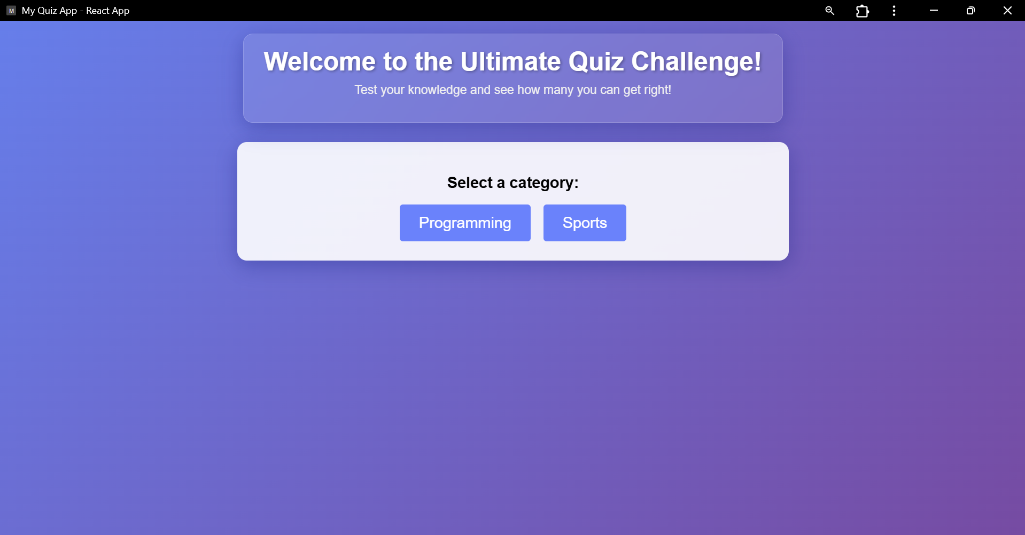

**Conclusion:-**

Hence, we learnt how to write a metadata of our website PWA in a Web App Manifest File to enable add to homescreen feature.

MAD & PWA Lab

Journal

|  |  |
| --- | --- |
| Experiment No. | 08 |
| Experiment Title. | To code and register a service worker, and complete the install and activation process for a new service worker for the E-commerce PWA |
| Roll No. | 10 |
| Name | Chirag A Choudhary |
| Class | D15A |
| Subject | MAD & PWA Lab |
| Lab Outcome | LO5: Design and Develop a responsive User Interface by applying PWA Design techniques |
| Grade: |  |

**EXPERIMENT 8**

|  |  |
| --- | --- |
| **Name** | **Roll No.** |
| Chirag Choudhary | **10** |
| Riya Varyani | **61** |

**Aim**: To code and register a service worker, and complete the install and activation process for a new service worker for the PWA.

**Theory**:

**Service Worker**

Service Worker is a script that works on browser background without user interaction independently. Also, It resembles a proxy that works on the user side. With this script, you can track network traffic of the page, manage push notifications and develop “offline first” web applications with Cache API.

Things to note about Service Worker:

● A service worker is a programmable network proxy that lets you control how network requests from your page are handled.

● Service workers only run over HTTPS. Because service workers can intercept network requests and modify responses, "man-in-the-middle" attacks could be very bad.

● The service worker becomes idle when not in use and restarts when it's next needed. You cannot rely on a global state persisting between events. If there is information that you need to persist and reuse across restarts, you can use IndexedDB databases.

**What can we do with Service Workers?**

**●** You can dominate **Network Traffic**

You can manage all network traffic of the page and do any manipulations. For example, when the page requests a CSS file, you can send plain text as a response or when the page requests an HTML file, you can send a png file as a response. You can also send a true response too.

**●** You can **Cache**

You can cache any request/response pair with Service Worker and Cache API and you can access these offline content anytime.

**●** You can manage **Push Notifications**

You can manage push notifications with Service Worker and show any information message to the user.

**●** You can **Continue**

Although Internet connection is broken, you can start any process with Background Sync of Service Worker.

**What can’t we do with Service Workers?**

**●** You can’t access the **Window**

You can’t access the window, therefore, You can’t manipulate DOM elements. But, you can communicate to the window through post Message and manage processes that you want.

**●** You can’t work it on **80 Port**

Service Worker just can work on HTTPS protocol. But you can work on localhost during development.

**Service Worker Cycle**

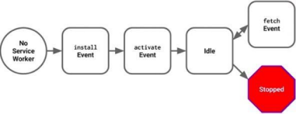A service worker goes through three steps in its life cycle:

● Registration

● Installation

● Activation

**Registration**

To install a service worker, you need to register it in your main JavaScript code

if ('serviceWorker' in navigator) {

navigator.serviceWorker.register('/service-worker.js')

.then(function(registration) {

console.log('Registration successful, scope is:', registration.scope);

})

.catch(function(error) {

console.log('Service worker registration failed, error:', error);

});

}

This code starts by checking for browser support by examining **navigator.serviceWorker**. The service worker is then registered with navigator.serviceWorker.register, which returns a promise that resolves when the service worker has been successfully registered. The scope of the service worker is then logged with registration.scope. If the service worker is already installed, navigator.serviceWorker.register returns the registration object of the currently active service worker.

The scope of the service worker determines which files the service worker controls, in other words, from which path the service worker will intercept requests. The default scope is the location of the service worker file, and extends to all directories below. So if service-worker.js is located in the root directory, the service worker will control requests from all files at this domain.

You can also set an arbitrary scope by passing in an additional parameter when registering. For example: main.js

navigator.serviceWorker.register('/service-worker.js', {

scope: '/app/'

});

In this case we are setting the scope of the service worker to /app/, which means the service worker will control requests from pages like /app/, /app/lower/ and /app/lower/lower, but not from pages like /app or /, which are higher.

If you want the service worker to control higher pages e.g. /app (without the trailing slash) you can indeed change the scope option, but you'll also need to set the Service-Worker-Allowed HTTP Header in your server config for the request serving the service worker script.

main.js

// Service Worker Script

const CACHE_NAME = 'blogbreeze-v1'; // Cache name to identify the version of cached content const urlsToCache = [

'/', // Home page

'index.html', // Main HTML file

'ani.html', // Any additional pages you want to cache

'/src/assets/react.svg', // App icon

'/public/icon.png', // Favicon

'/src/main.jsx', // Main JS file for app functionality

// 'https://cdnjs.cloudflare.com/ajax/libs/font-awesome/6.0.0-beta3/css/all.min.css' // FontAwesome for icons

];

// Install Service Worker

self.addEventListener('install', (event) => {

console.log('Service Worker: Installed');

event.waitUntil(

caches.open(CACHE_NAME)

.then((cache) => {

return cache.addAll(urlsToCache);

})

);

});

// Activate Service Worker

self.addEventListener('activate', (event) => {

console.log('Service Worker: Activated');

// Remove old caches if there are any

event.waitUntil(

caches.keys().then((cacheNames) => {

return Promise.all(

cacheNames.map((cacheName) => {

if (cacheName !== CACHE_NAME) {

return caches.delete(cacheName);

}

})

);

})

);

});

// Fetch event: Intercept network requests and serve cached content

self.addEventListener('fetch', (event) => {

console.log('Service Worker: Fetching', event.request.url);

event.respondWith(

caches.match(event.request)

.then((cachedResponse) => {

// Return cached content if found, otherwise fetch from network

return cachedResponse || fetch(event.request);

})

);

})

// Service Worker Script

const CACHE_NAME = 'blogbreeze-v1'; // Cache name to identify the version of cached content const urlsToCache = [

'/', // Home page

'index.html', // Main HTML file

'ani.html', // Any additional pages you want to cache

'/src/assets/react.svg', // App icon

'/public/icon.png', // Favicon

'/src/main.jsx', // Main JS file for app functionality

// 'https://cdnjs.cloudflare.com/ajax/libs/font-awesome/6.0.0-beta3/css/all.min.css' // FontAwesome for icons

];

// Install Service Worker

self.addEventListener('install', (event) => {

console.log('Service Worker: Installed');

event.waitUntil(

caches.open(CACHE_NAME)

.then((cache) => {

return cache.addAll(urlsToCache);

})

);

});

// Activate Service Worker

self.addEventListener('activate', (event) => {

console.log('Service Worker: Activated');

// Remove old caches if there are any

event.waitUntil(

caches.keys().then((cacheNames) => {

return Promise.all(

cacheNames.map((cacheName) => {

if (cacheName !== CACHE_NAME) {

return caches.delete(cacheName);

}

})

);

})

);

});

// Fetch event: Intercept network requests and serve cached content self.addEventListener('fetch', (event) => {

console.log('Service Worker: Fetching', event.request.url); event.respondWith(

caches.match(event.request)

.then((cachedResponse) => {

// Return cached content if found, otherwise fetch from network return cachedResponse || fetch(event.request);

})

);

});

navigator.serviceWorker.register('/app/service-worker.js',

{ scope: '/app'

});

**Installation**

Once the browser registers a service worker, installation can be attempted. This occurs if the service worker is considered to be new by the browser, either because the site currently doesn't have a registered service worker, or because there is a byte difference between the new service worker and the previously installed one.

A service worker installation triggers an install event in the installing service worker. We can include an install event listener in the service worker to perform some task when the service worker installs. For instance, during the install, service workers can precache parts of a web app so that it loads instantly the next time a user opens it (see caching the application shell). So, after that first load, you're going to benefit from instant repeat loads and your time to interactivity is going to be even better in those cases. An example of an installation event listener looks like this:

service-worker.js

*// Listen for install event, set callback*

self.addEventListener('install', function(event) {

*// Perform some task*

});

**Activation**

Once a service worker has successfully installed, it transitions into the activation stage. If there are any open pages controlled by the previous service worker, the new service worker enters a waiting state. The new service worker only activates when there are no longer any pages loaded that are still using the old service worker. This ensures that only one version of the service worker is running at any given time.

When the new service worker activates, an activate event is triggered in the activating service worker. This event listener is a good place to clean up outdated caches (see the Offline Cookbook for an example).

Once activated, the service worker controls all pages that load within its scope, and starts listening for events from those pages. However, pages in your app that were loaded before the service worker activation will not be under service worker control. The new service worker will only take over when you close and reopen your app, or if the service worker calls **clients.claim()**. Until then, requests from this page will not be intercepted by the new service worker. This is intentional as a way to ensure consistency in your site.

**Code** :

// Service Worker Script

const CACHE_NAME = 'blogbreeze-v1'; // Cache name to identify the version of cached content const urlsToCache = [

'/', // Home page

'index.html', // Main HTML file

'ani.html', // Any additional pages you want to cache

'/src/assets/react.svg', // App icon

'/public/icon.png', // Favicon

'/src/main.jsx', // Main JS file for app functionality

// 'https://cdnjs.cloudflare.com/ajax/libs/font-awesome/6.0.0-beta3/css/all.min.css' // FontAwesome for icons

];

// Install Service Worker

self.addEventListener('install', (event) => {

console.log('Service Worker: Installed');

event.waitUntil(

caches.open(CACHE_NAME)

.then((cache) => {

return cache.addAll(urlsToCache);

})

);

});

// Activate Service Worker

self.addEventListener('activate', (event) => {

console.log('Service Worker: Activated');

// Remove old caches if there are any

event.waitUntil(

caches.keys().then((cacheNames) => {

return Promise.all(

cacheNames.map((cacheName) => {

if (cacheName !== CACHE_NAME) {

return caches.delete(cacheName);

}

})

);

})

);

});

// Fetch event: Intercept network requests and serve cached content self.addEventListener('fetch', (event) => {

console.log('Service Worker: Fetching', event.request.url); event.respondWith(

caches.match(event.request)

.then((cachedResponse) => {

// Return cached content if found, otherwise fetch from network return cachedResponse || fetch(event.request);

})

);

});

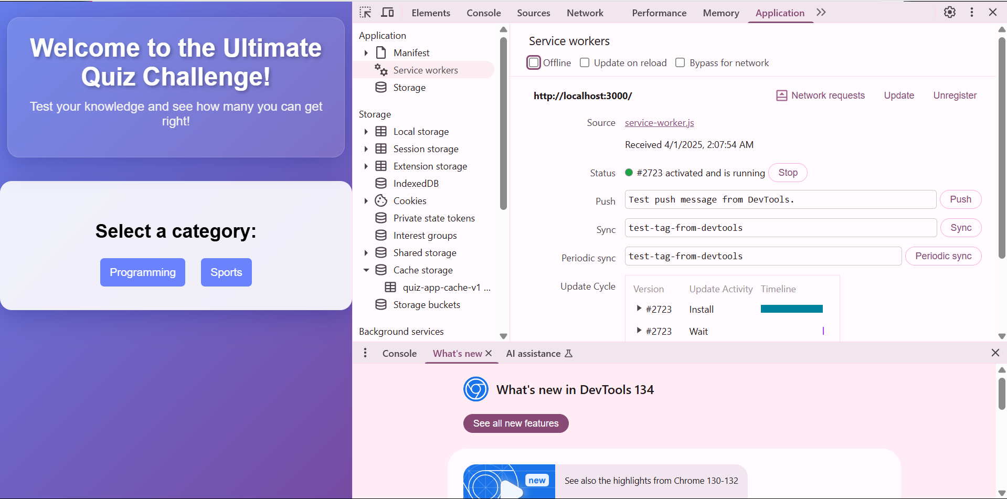

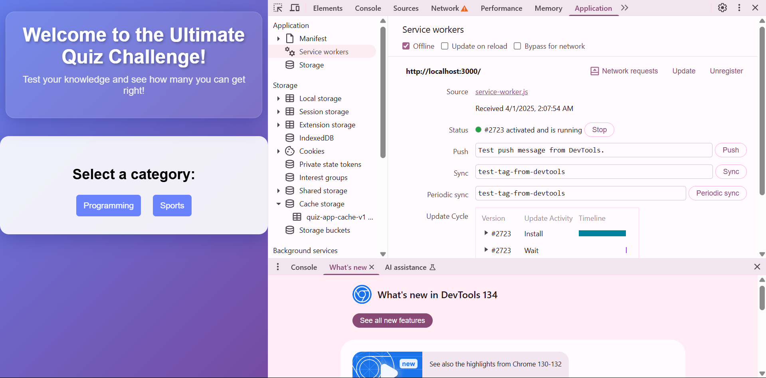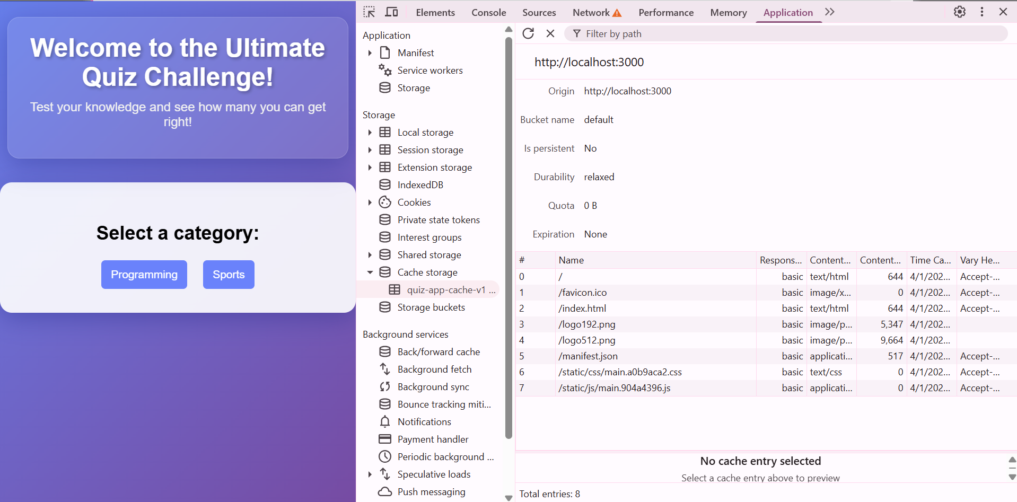

Conclusion : Thus we have learnt to code and register a service worker, and complete the install and activation process for a new service worker for the PWA.

MAD & PWA Lab

Journal

|  |  |
| --- | --- |
| Experiment No. | 09 |
| Experiment Title. | To implement Service worker events like fetch, sync and push for E-commerce PWA |
| Roll No. | 10 |
| Name | Chirag A Choudhary |
| Class | D15A |
| Subject | MAD & PWA Lab |
| Lab Outcome | LO5: Design and Develop a responsive User Interface by applying PWA Design techniques |
| Grade: |  |

**EXPERIMENT NO. 9**

**Aim**: To implement Service worker events like fetch, sync and push for E-commerce PWA.

# Theory:

**Service Worker**

Service Worker is a script that works on browser background without user interaction independently. Also, It resembles a proxy that works on the user side. With this script, you can track network traffic of the page, manage push notifications and develop “offline first” web applications with Cache API.

Things to note about Service Worker:

* A service worker is a programmable network proxy that lets you control how network requests from your page are handled.
* Service workers only run over HTTPS. Because service workers can intercept network requests and modify responses, "man-in-the-middle" attacks could be very bad.
* The service worker becomes idle when not in use and restarts when it's next needed. You cannot rely on a global state persisting between events. If there is information that you need to persist and reuse across restarts, you can use IndexedDB databases.
* Service workers make extensive use of promises, so if you're new to promises, then you should stop reading this and check out Promises, an introduction.

# Fetch Event

You can track and manage page network traffic with this event. You can check existing cache, manage “cache first” and “network first” requests and return a response that you want.

Of course, you can use many different methods but you can find in the following example a “cache first” and “network first” approach. In this example, if the request’s and current location’s origin are the same (Static content is requested.), this is called “cacheFirst” but if you request a targeted external URL, this is called “networkFirst”.

* **CacheFirst** - In this function, if the received request has cached before, the cached response is returned to the page. But if not, a new response requested from the network.
* **NetworkFirst** - In this function, firstly we can try getting an updated response from the network, if this process completed successfully, the new response will be cached and returned. But if this process fails, we check whether the request has been cached before or not. If a cache exists, it is returned to the page, but if not, this is up to you. You can return dummy content or information messages to the page.

# Sync Event

Background Sync is a Web API that is used to delay a process until the Internet connection is stable. We can adapt this definition to the real world; there is an e-mail client application that works on the browser and we want to send an email with this tool. Internet connection is broken while we are writing e-mail content and we didn’t realize it. When completing the writing, we click the send button.

Here is a job for the Background Sync.

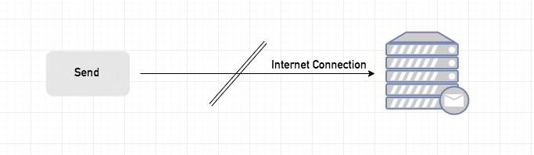The following view shows the classical process of sending email to us. If the Internet Connection is broken, we can’t send any content to Mail Server.

Here, you can create any scenario for yourself. A sample is in the following for this case.

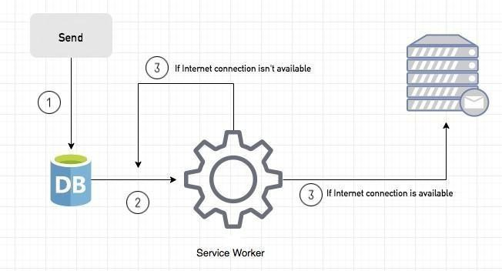

1. When we click the “send” button, email content will be saved to IndexedDB.
2. Background Sync registration.
3. **If the Internet connection is available**, all email content will be read and sent to Mail Server.

**If the Internet connection is unavailable**, the service worker waits until the connection is available even though the window is closed. When it is available, email content will be sent to Mail Server.

You can see the working process within the following code block.

Event Listener for Background Sync Registration

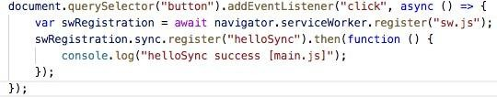

Event Listener for sw.js

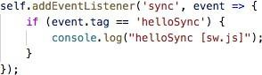

# Push Event

This is the event that handles push notifications that are received from the server. You can apply any method with received data.

We can check in the following example.

“Notification.requestPermission();” is the necessary line to show notification to the user. If you don’t want to show any notification, you don’t need this line.

In the following code block is in sw.js file. You can handle push notifications with this event. In this example, I kept it

simple. We send an object that has “method” and “message” properties. If the method value is “pushMessage”, we open the information notification with the “message” proper.

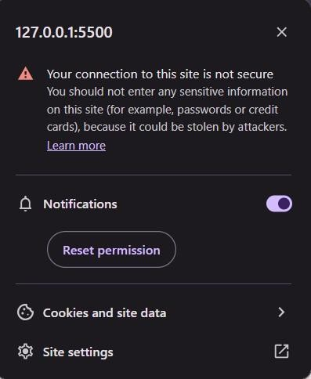

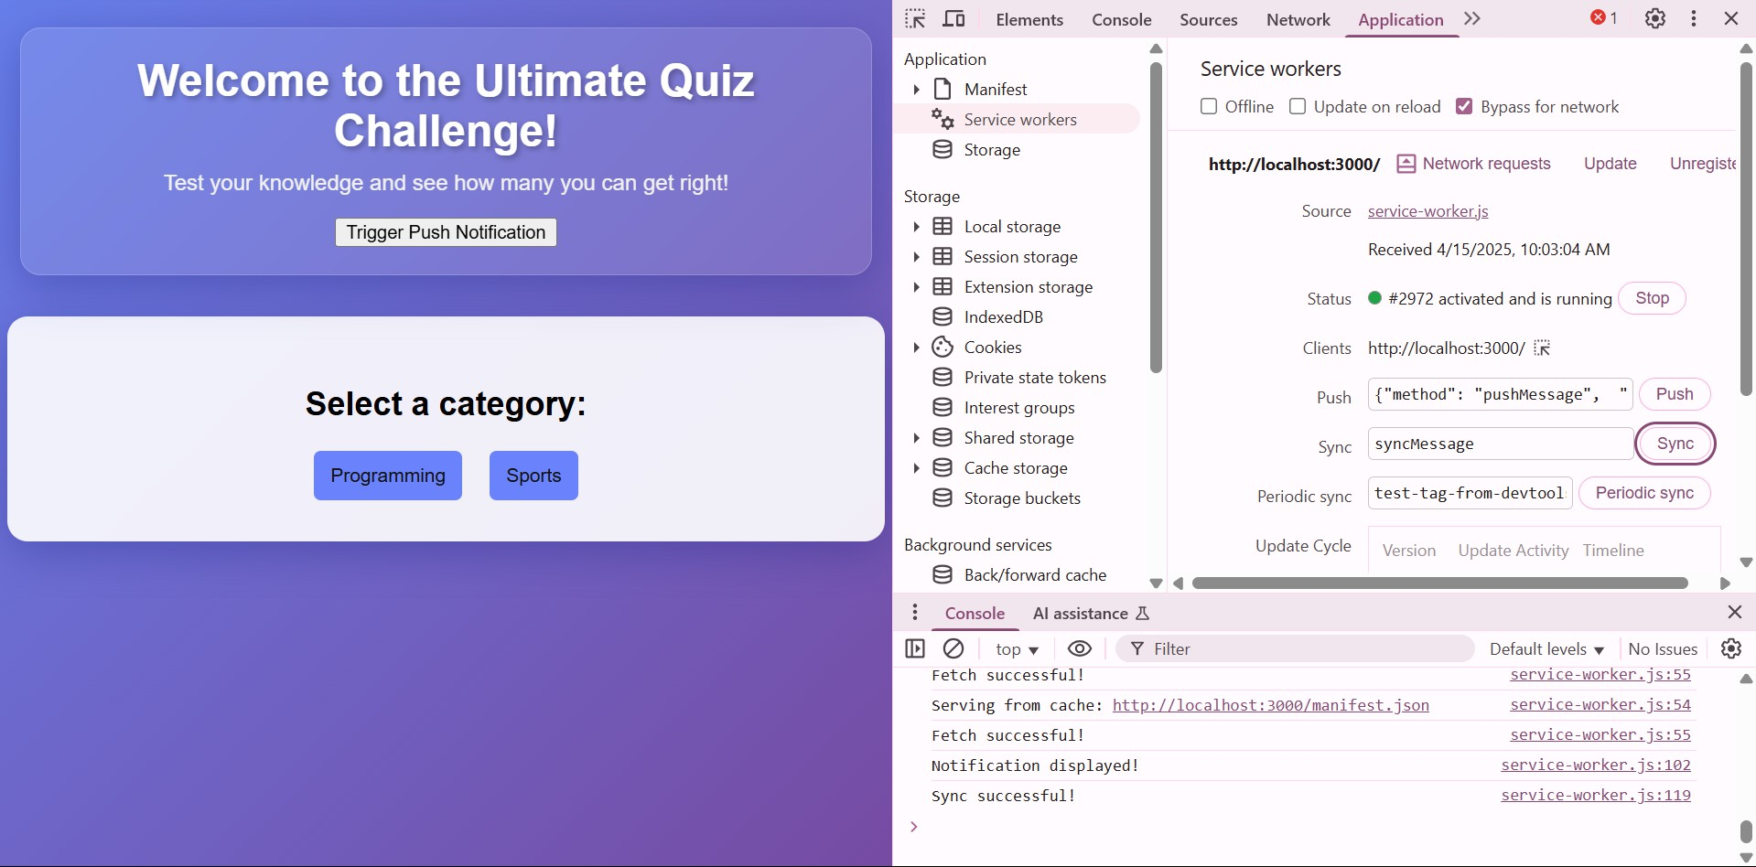

MAD & PWA Lab

Journal

|  |  |
| --- | --- |
| Experiment No. | 10 |
| Experiment Title. | To study and implement deployment of Ecommerce PWA to GitHub Pages. |
| Roll No. | 10 |
| Name | Chirag A Choudhary |
| Class | D15A |
| Subject | MAD & PWA Lab |
| Lab Outcome | LO5: Design and Develop a responsive User Interface by applying PWA Design techniques |
| Grade: |  |

**EXPERIMENT NO: - 10**

**AIM: -** To study and implement deployment of Ecommerce PWA to GitHub Pages. **Theory: -**

**GitHub Pages: Static Website Hosting Made Simple**

GitHub Pages is a free hosting service that allows users to publish **public webpages directly from a GitHub repository**. It is particularly useful for **static websites, project documentation, and blogs**.

**Key Features**

● **Jekyll Integration**: Built-in support for Jekyll enables easy blogging.

● **Custom Domains**: Allows users to configure their own URLs.

● **Automatic Page Deployment**: Simply push your changes to the repository, and the updates go live.

**Why Choose GitHub Pages?**

● **Completely Free**: No hosting charges.

● **Seamless GitHub Integration**: Works directly with your repositories.

● **Quick Setup**: Just create a repository, push your files, and your site is live.

**Who Uses GitHub Pages?**

Companies like **Lyft, CircleCI, and HubSpot** use GitHub Pages for their documentation and static sites. It is widely adopted, appearing in **775 company stacks and 4,401 developer stacks**.

**Pros & Cons**

**Pros**

● Familiar interface for GitHub users.

Sonam chhabaidiya/ palak Chanchlani/ Mahi jodhani D15A 09/05/21

● Simple deployment via the gh-pages branch.

● Supports custom domains with easy DNS configuration.

**Cons**

● Repositories need to be public unless you have a paid plan.

● Limited HTTPS support for custom domains (expected to improve).

● Jekyll plugins have limited support.

**Firebase: A Full-Featured Real-Time Backend**

Firebase is a cloud-based **real-time application platform** developed by Google. It enables developers to build **dynamic, collaborative applications** with ease.

**Key Features**

● **Real-Time Database**: Automatically syncs data across all connected clients. ● **Cloud-Based Storage**: JSON-based storage accessible via REST APIs. ● **Scalable Infrastructure**: Works well with existing services and scales automatically. ● **Authentication & Cloud Messaging**: Secure login and push notifications.

**Why Choose Firebase?**

● **Instant Backend Setup**: No need to build a separate backend.

● **Fast & Responsive**: Real-time data synchronization.

● **Built-in HTTPS**: Free SSL certificates for custom domains.

**Who Uses Firebase?**

Companies like **Instacart, 9GAG, and Twitch** rely on Firebase for their backend needs. Firebase is widely adopted, appearing in **1,215 company stacks and 4,651 developer stacks**.

**Pros & Cons**

Sonam chhabaidiya/ palak Chanchlani/ Mahi jodhani D15A 09/05/21

**Pros**

● **Hosted by Google**, ensuring reliability and security.

● **Comes with authentication, messaging, and real-time database services.** ● **Free HTTPS support** for all custom domains.

**Cons**

● **Limited Free Plan**: 10 GB of data transfer per month (can be mitigated with a CDN). ● **Command-Line Deployment**: No GUI for hosting.

● **No Built-in Static Site Generator Support**: Unlike GitHub Pages, Firebase doesn’t natively support static site generators like Jekyll.

**Link to our GitHub repository:**

**https://github.com/Chirag7270/IP-mini-project**

**Hosted link:**

**https://chirag7270.github.io/IP-mini-project/**

**Github Screenshot:**

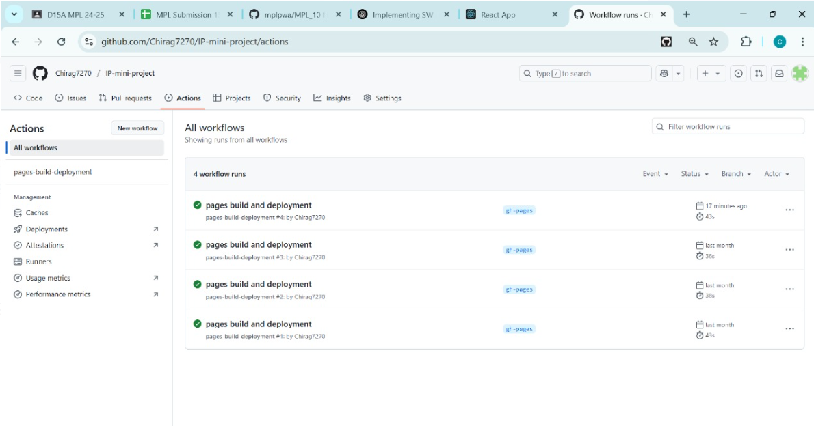

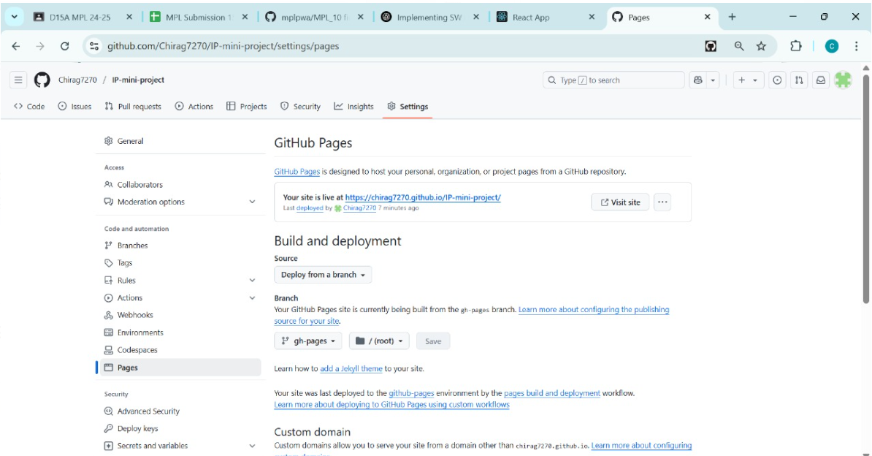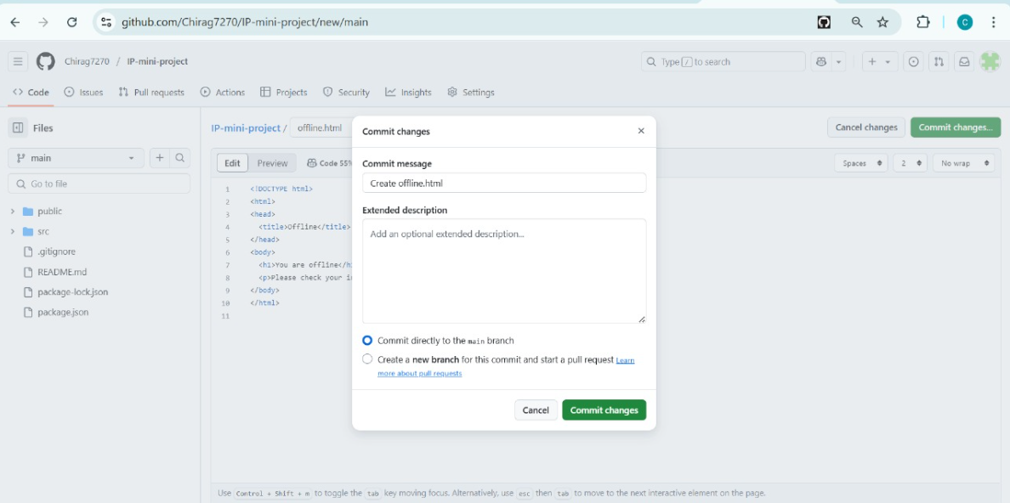

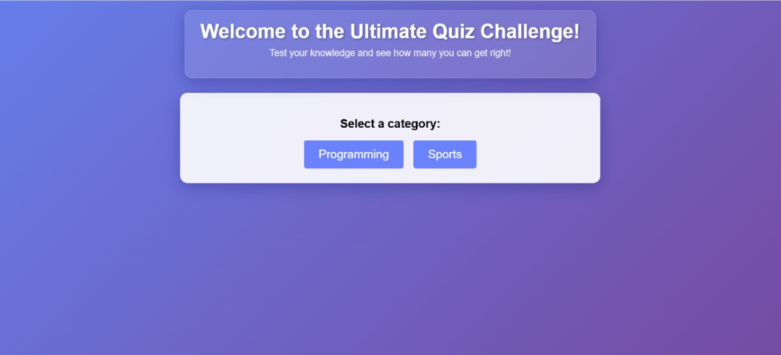

MAD & PWA Lab

Journal

|  |  |
| --- | --- |
| Experiment No. | 11 |
| Experiment Title. | To use google Lighthouse PWA Analysis Tool to test the PWA functioning. |
| Roll No. | 10 |
| Name | Chirag A Choudhary |
| Class | D15A |
| Subject | MAD & PWA Lab |
| Lab Outcome | LO6: Develop and Analyze PWA Features and deploy it over app hosting solution |
| Grade: |  |

**PWA Experiment 11**

|  |  |
| --- | --- |
| **Name** | **Roll No.** |
| Chirag Choudhary | 10 |
| Riya Varyani | 61 |

**Aim :** To use google Lighthouse PWA Analysis Tool to test the PWA functioning.

**Theory :**

Reference : https://www.semrush.com/blog/google-lighthouse/

**Google Lighthouse :**

Google Lighthouse is a tool that lets you audit your web application based on a number of parameters including (but not limited to) performance, based on a number of metrics, mobile compatibility, Progressive Web App (PWA) implementations, etc. All you have to do is run it on a page or pass it a URL, sit back for a couple of minutes and get a very elaborate report, not much short of one that a professional auditor would have compiled in about a week.

The best part is that you have to set up almost nothing to get started. Let’s begin by looking at some of the top features and audit criteria used by Lighthouse.

**Key Features and Audit Metrics**

Google Lighthouse has the option of running the Audit for Desktop as well as mobile version of your page(s). The top metrics that will be measured in the Audit are:

1. **Performance:** This score is an aggregation of how the page fared in aspects such as (but not limited to) loading speed, time taken for loading for basic frame(s), displaying meaningful content to the user, etc. To a layman, this score is

indicative of how decently the site performs, with a score of 100 meaning that you figure in the 98th percentile, 50 meaning that you figure in the 75th

percentile and so on.

2. **PWA Score (Mobile):** Thanks to the rise of Service Workers, app manifests, etc., a lot of modern web applications are moving towards the PWA paradigm, where the objective is to make the application behave as close as possible to native mobile applications. Scoring points are based on the Baseline PWA checklist laid down by Google which includes Service Worker implementation(s), viewport handling, offline functionality, performance in script-disabled environments, etc.

3. **Accessibility:** As you might have guessed, this metric is a measure of how accessible your website is, across a plethora of accessibility features that can be implemented in your page (such as the ‘aria-’ attributes like aria-required, audio captions, button names, etc.). Unlike the other metrics though, Accessibility metrics score on a pass/fail basis i.e. if all possible elements of the page are not screen-reader friendly (HTML5 introduced features that would make pages easy to interpret for screen readers used by visually challenged people like tag names, tags such as <section>, <article>, etc.), you get a 0 on that score. The aggregate of these scores is your Accessibility metric score.

4. **Best Practices:** As any developer would know, there are a number of practices that have been deemed ‘best’ based on empirical data. This metric is an

aggregation of many such points, including but not limited to:Use of HTTPS Avoiding the use of deprecated code elements like tags, directives,

libraries, etc. Password input with paste-into disabled

Geo-Location and cookie usage alerts on load, etc.

Performance before changes

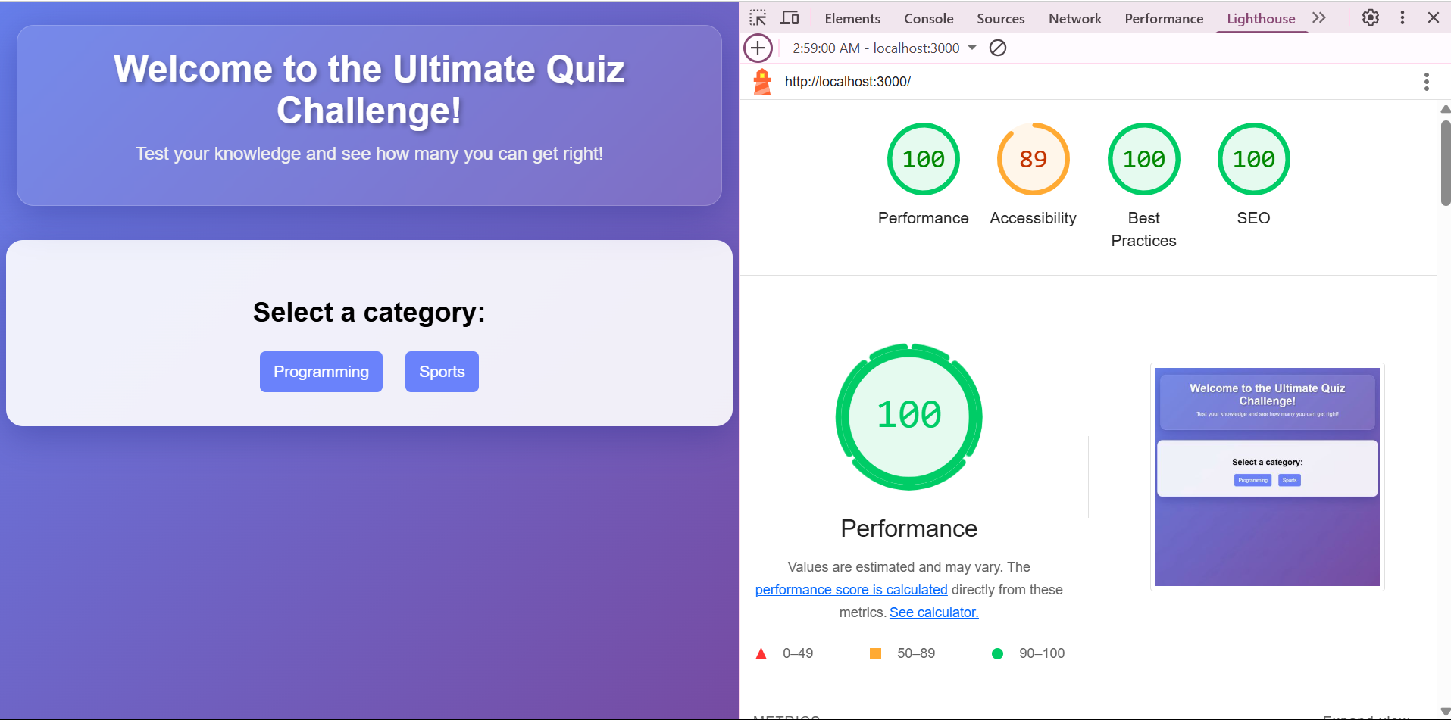

Performance after changes

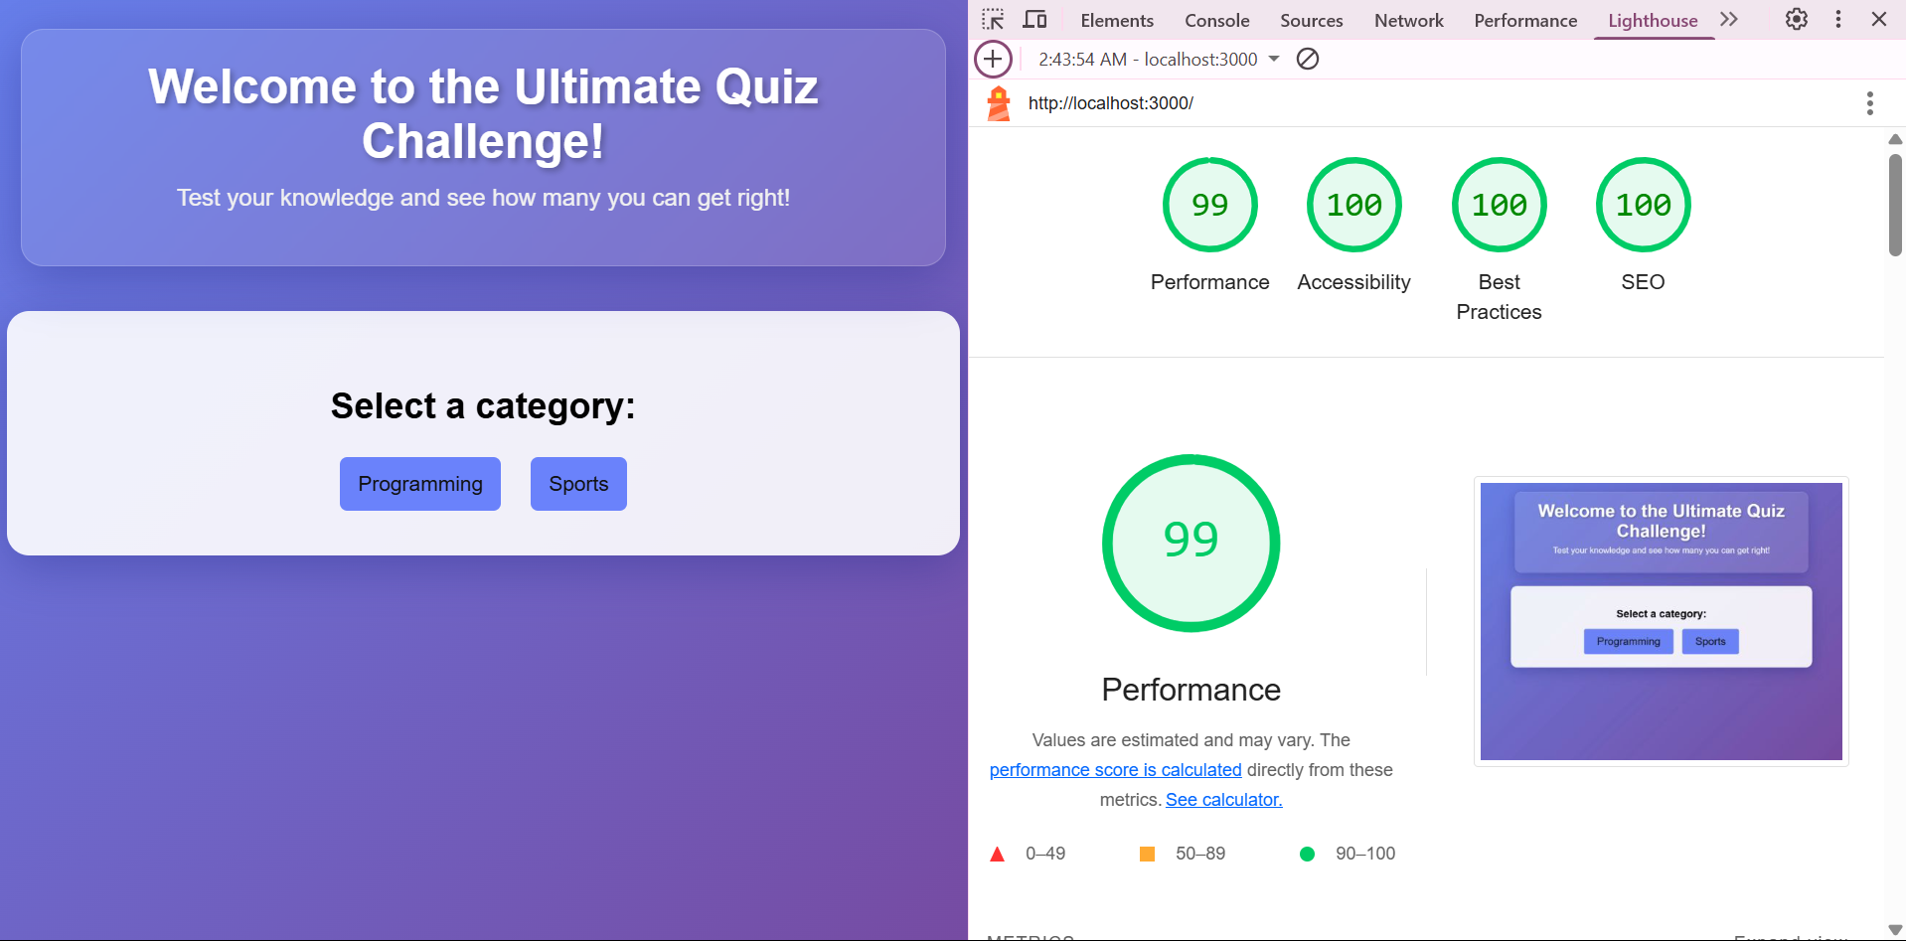

**Conclusion:** Thus we successfully used google Lighthouse PWA Analysis Tool for testing the PWA functioning.

MAD & PWA Lab

Journal

|  |  |
| --- | --- |
| Experiment No. | Assignment-1 |
| Assignment 1 Questions | 1. Flutter Overview:Explain the key features and advantages of using Flutter for mobile app development. Discuss how the Flutter framework differs from traditional approaches and why it has gained popularity in the developer community.  2. Widget Tree and Composition: Describe the concept of the widget tree in Flutter. Explain how widget composition is used to build complex user interfaces. Provide examples of commonly used widgets and their roles in creating a widget tree.  3. State Management in Flutter: Discuss the importance of state management in Flutter applications. Compare and contrast the different state management approaches available in Flutter, such as setState, Provider, and Riverpod. Provide scenarios where each approach is suitable.  4. Firebase Integration in Flutter: Explain the process of integrating Firebase with a Flutter application. Discuss the benefits of using Firebase as a backend solution. Highlight the Firebase services commonly used in Flutter development and provide a brief overview of how data synchronization is achieved. |
| Roll No. | 10 |
| Name | Chirag A Choudhary |
| Class | D15A |
| Subject | MAD & PWA Lab |
| Lab Outcome | LO1: Understand cross platform mobile application development using Flutter framework  LO2: Design and Develop interactive Flutter App by using widgets, layouts, gestures and animation  LO3: Analyze and Build production ready Flutter App by incorporating backend services and deploying on Android / iOS |
| Grade: |  |

MAD & PWA Lab

Journal

|  |  |
| --- | --- |
| Experiment No. | Assignment-2 |
| Assignment 2 Questions | 1. Define Progressive Web App (PWA) and explain its significance in modern web development.Discuss the key characteristics that differentiate PWAs from traditional mobile apps 2. Define responsive web design and explain its importance in the context of Progressive Web Apps.Compare and contrast responsive, fluid, and adaptive web design approaches. 3. Describe the lifecycle of Service Workers, including registration, installation, and activation phases. 4. Explain the use of IndexedDB in the Service Worker for data storage. |
| Roll No. | 10 |
| Name | Chirag A Choudhary |
| Class | D15A |
| Subject | MAD & PWA Lab |
| Lab Outcome | LO4:Understand various PWA frameworks and their requirements  LO5: Design and Develop a responsive User Interface by applying PWA Design techniques  LO6:Develop and Analyze PWA Features and deploy it over app hosting solutions |
| Grade: |  |